**ArgoCD and Gitea Setup in an Air Gapped Environment**

Follow these steps to install ArgoCD and Gitea in an air gapped environment. I was able to set up ArgoCD in a VM with a Minikube cluster. Since I have to use an environment with no internet connection (Air Gapped Environment), I have chosen Minikube. As I was facing IP related issues with Kubeadm, I have chosen to go with Minikube. I have downloaded all the requirements, including the local registry in Minikube, the Docker images needed to run ArgoCD, and the manifest files before I turned off the internet. I have pushed images to the local repository and updated the image names in the manifest files. Run the below commands in the same order.

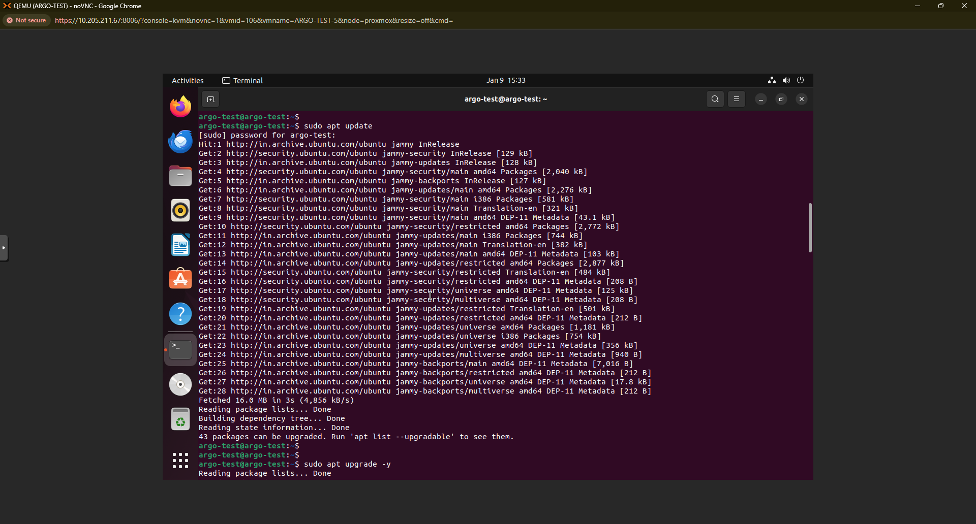

Update the apt repository.

**sudo apt update**

**sudo apt upgrade -y**

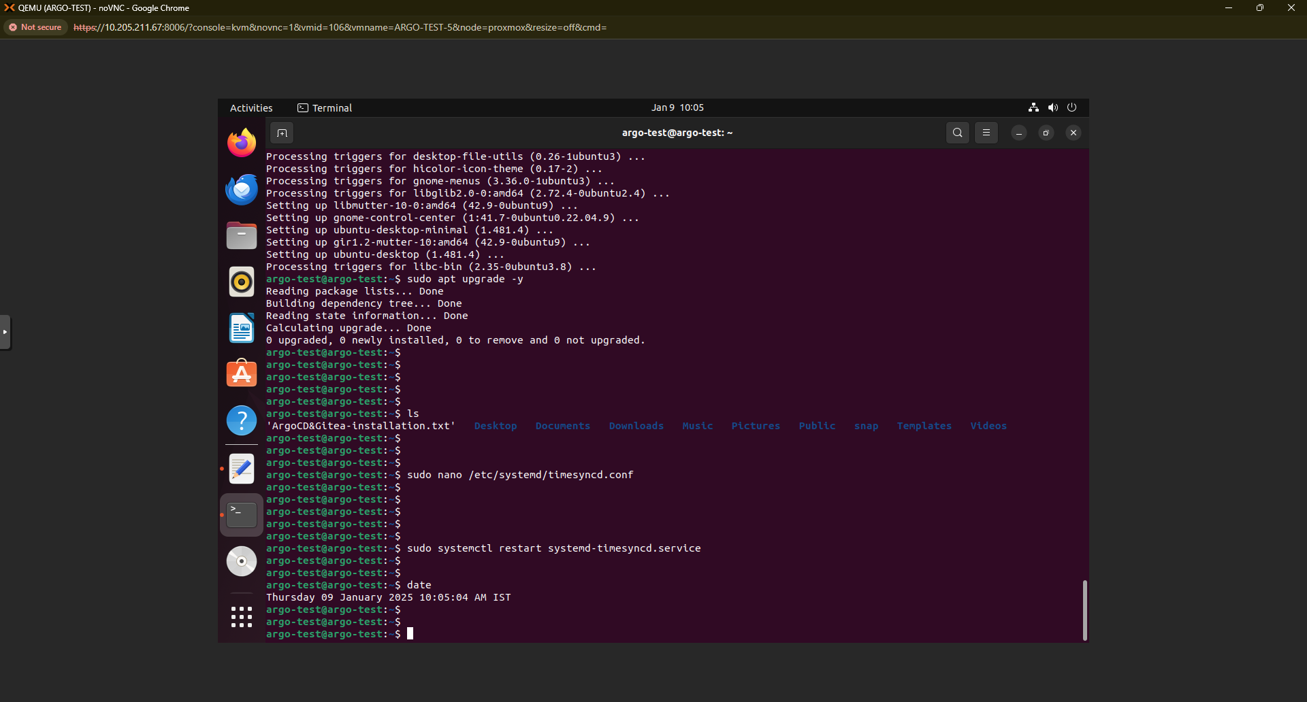

Open the **timesync.conf file** and update the NTP server details if there is any time sync issue in your system.

**sudo nano /etc/systemd/timesyncd.conf**

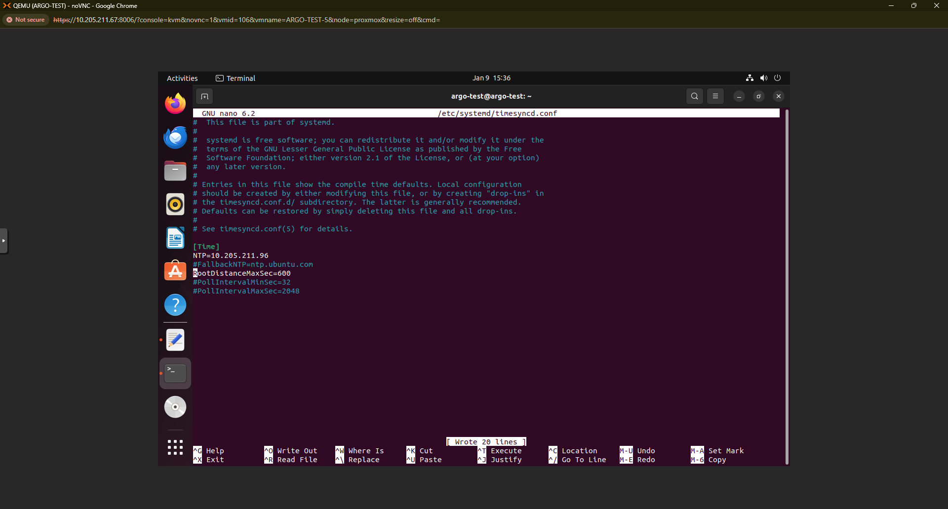



**sudo systemctl restart systemd-timesyncd.service**

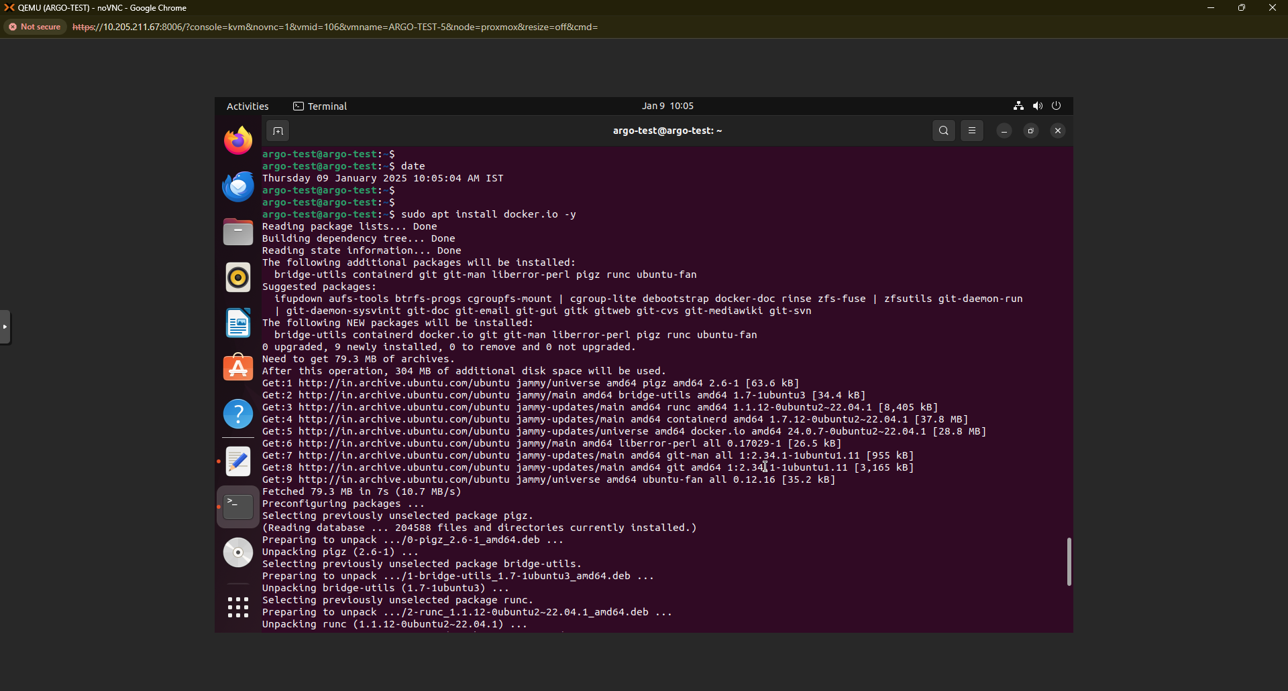

Install Docker and add the current user into the docker group to access images and running containers.

**sudo apt install docker.io -y**

**sudo usermod -aG docker argotest**

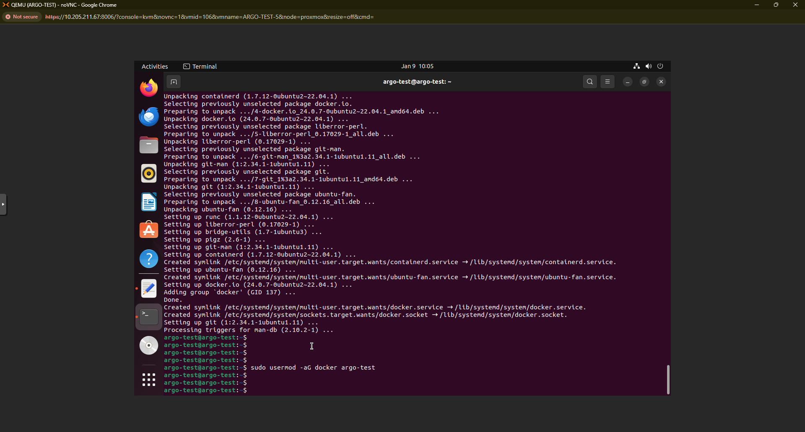

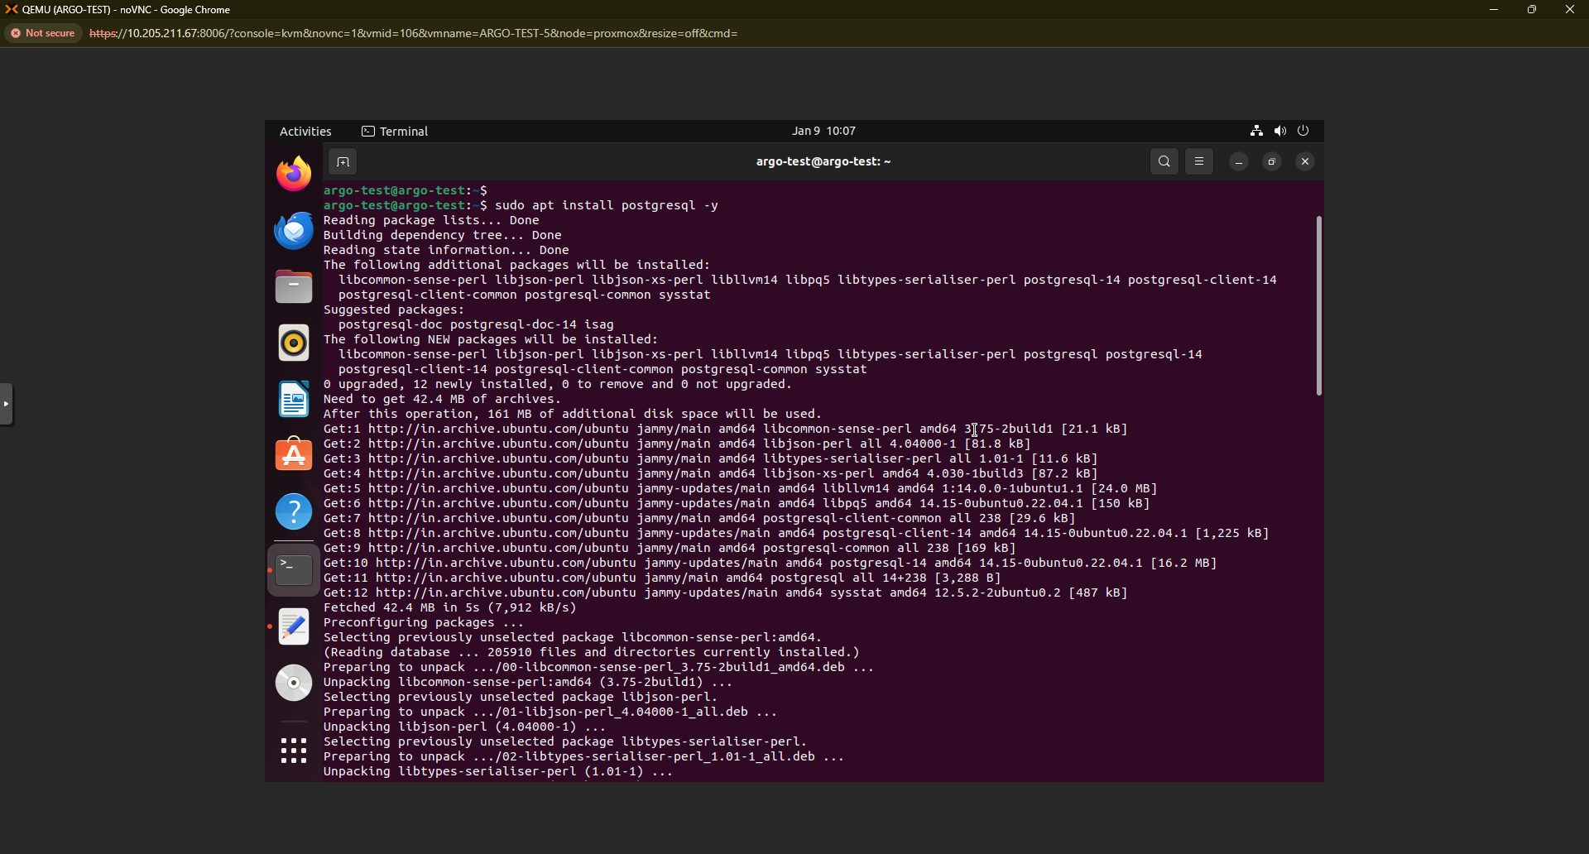

Install Postgres server in the VM. It is mandatory to run Gitea server.

**sudo apt install postgrsql -y**

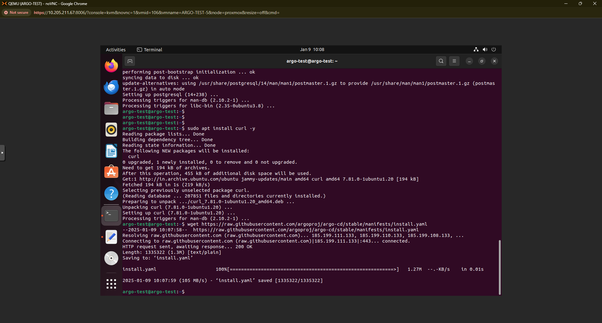

Install **CURL**

**sudo apt install curl -y**

Download Argocd manifest file from internet

**wget https://raw.githubusercontent.com/argoproj/argo-cd/stable/manifests/install.yaml**

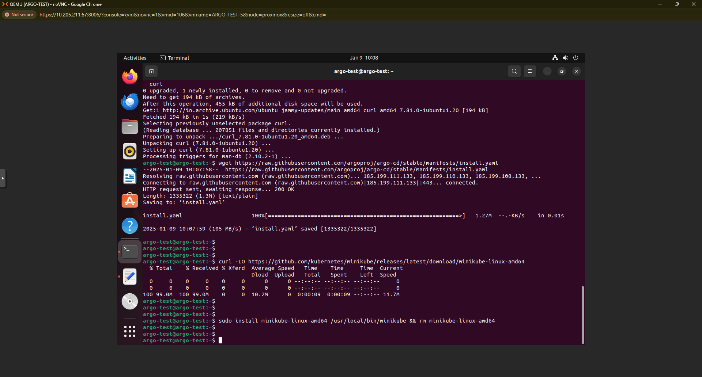

Now, Install **Minikube** by downloading necessary files from the internet.

**curl -LO** [**https://github.com/kubernetes/minikube/releases/latest/download/minikube-linux-amd64**](https://github.com/kubernetes/minikube/releases/latest/download/minikube-linux-amd64)

**sudo install minikube-linux-amd64 /usr/local/bin/minikube && rm minikube-linux-amd64**

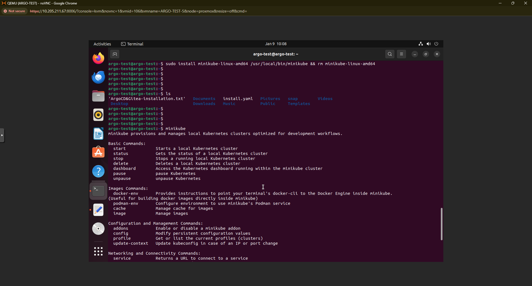

Verify the installation by running the below command.

**minikube**

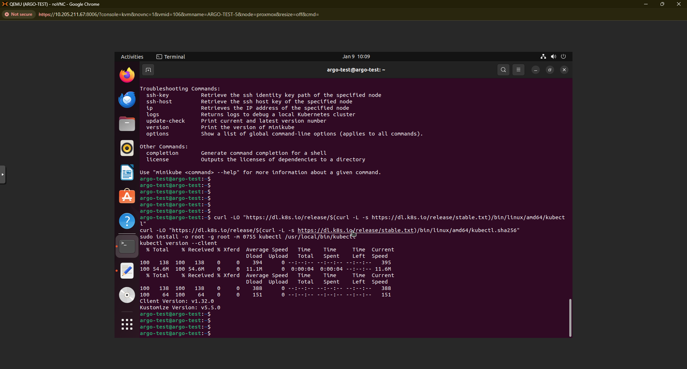

Install **kubectl** tool in the system.

**curl -LO "https://dl.k8s.io/release/$(curl -L -s** [**https://dl.k8s.io/release/stable.txt**](https://dl.k8s.io/release/stable.txt)**)/bin/linux/amd64/kubectl"**

**curl -LO "https://dl.k8s.io/release/$(curl -L -s** [**https://dl.k8s.io/release/stable.txt**](https://dl.k8s.io/release/stable.txt)**)/bin/linux/amd64/kubectl.sha256"**

**sudo install -o root -g root -m 0755 kubectl /usr/local/bin/kubectl**

**kubectl version --client**

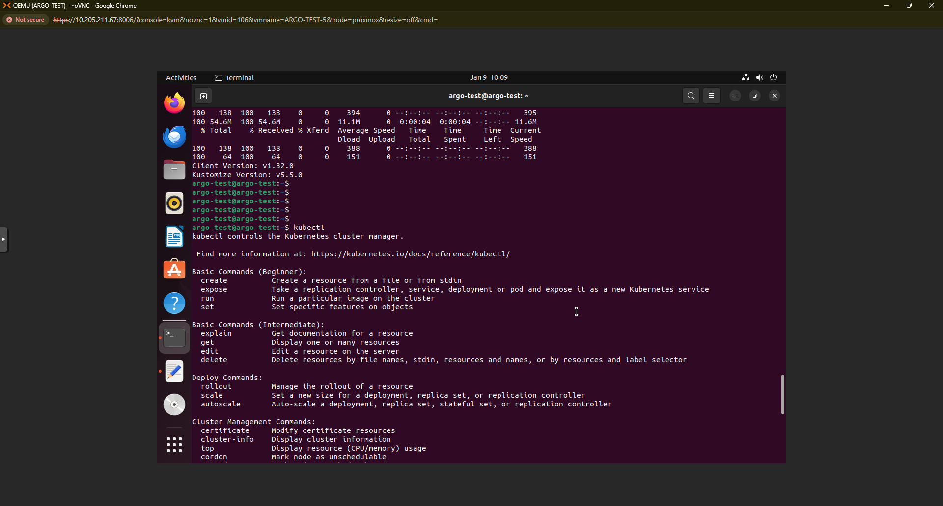

Verify the installation og kubectl.

**Kubectl**

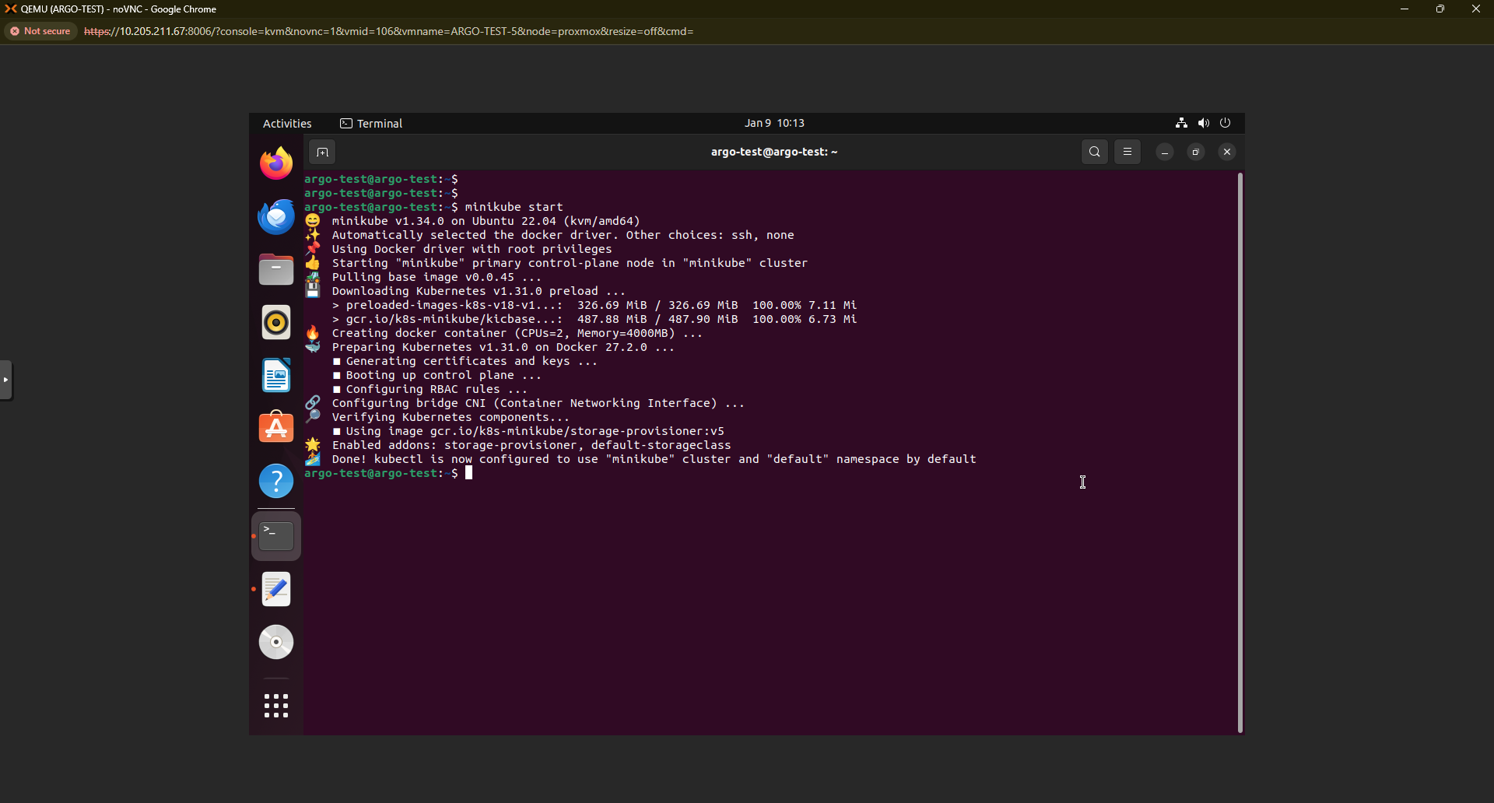

Now, start the Minikube cluster in the VM.

**minikube start**

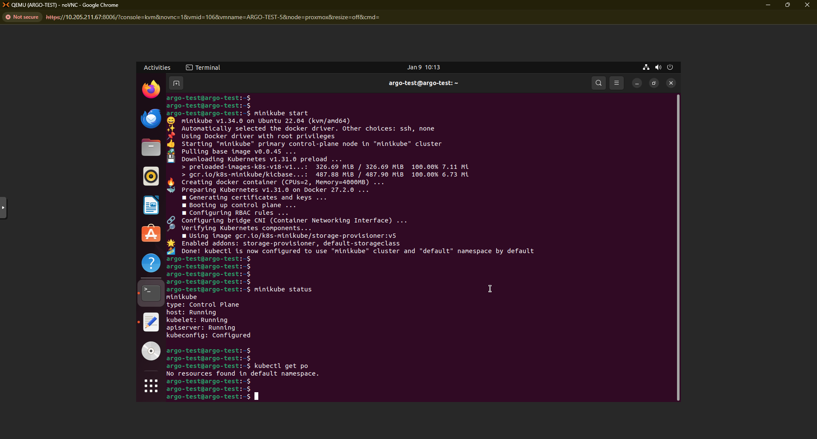

Check the Minikube cluster status and check if it is accessible with kubectl command.

**minikube status**

**kubectl get po**

**kubectl get ns**

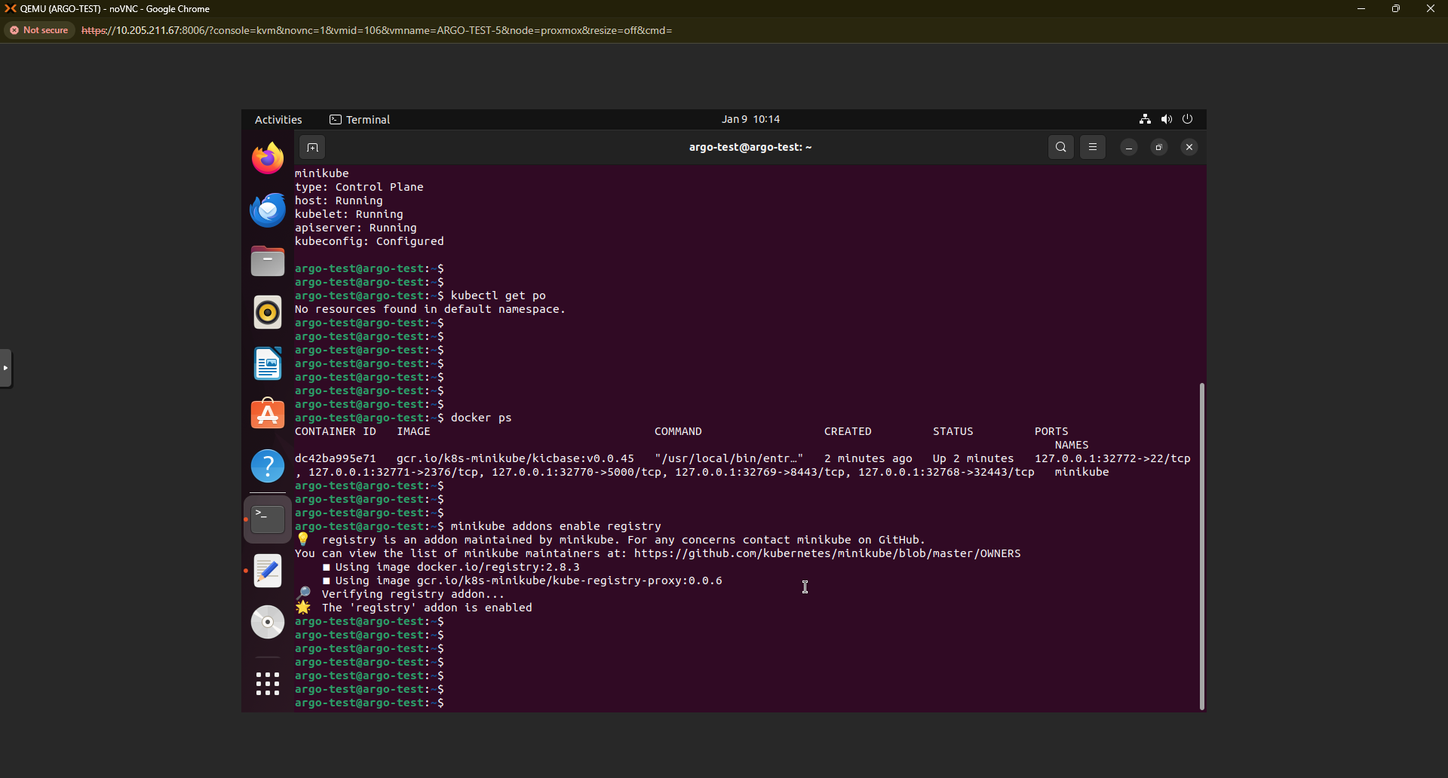

Check if there are any previous containers running in the system.

**docker ps**

Install a local registry in the Minikube cluster to store images that are needed to run containers.

**minikube addons enable registry**

Check the Minikube status again

**minikube status**

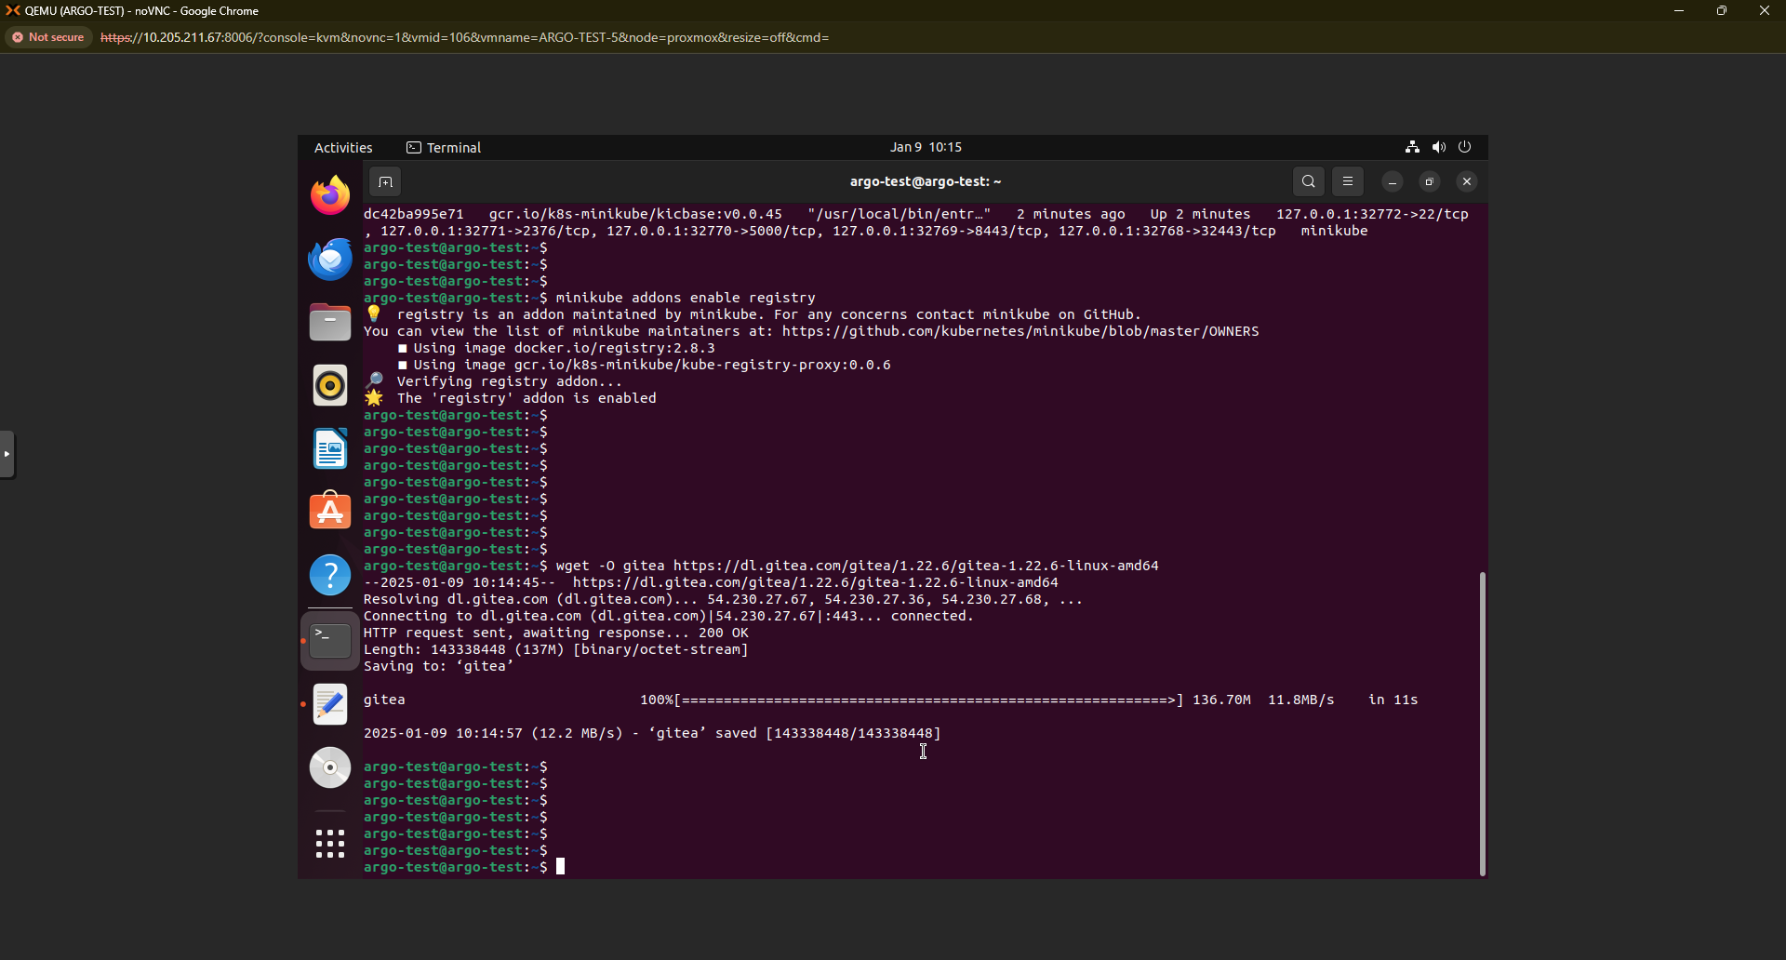

Download the Gitea binary file from the internet.

**wget -O gitea** [**https://dl.gitea.com/gitea/1.22.6/gitea-1.22.6-linux-amd64**](https://dl.gitea.com/gitea/1.22.6/gitea-1.22.6-linux-amd64)

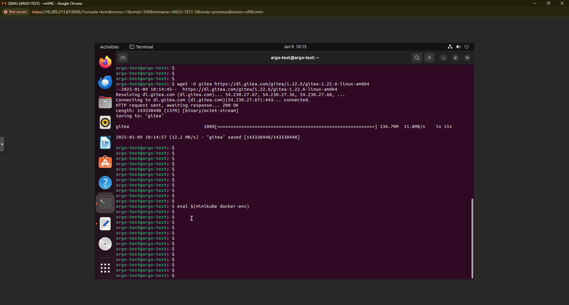

Run the command below to switch to the Minikube Docker environment and pull images there. This step is not necessary if you are not using Minikube

**eval $(minikube docker-env)**

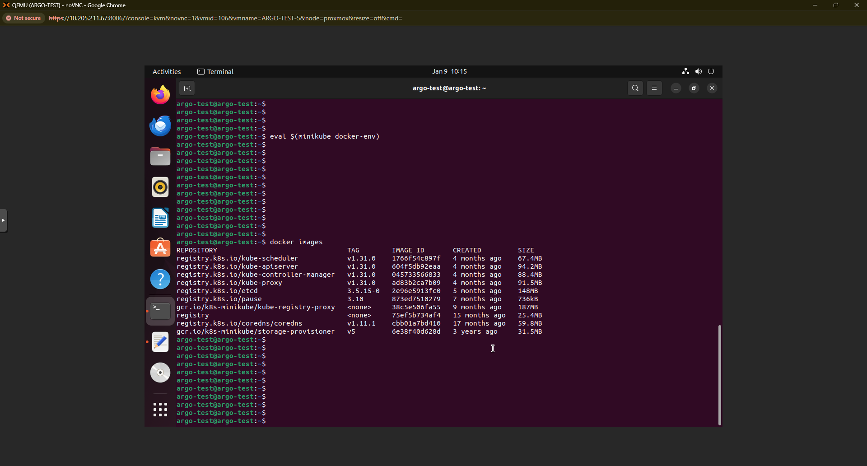

Check if images are available in the system.

**docker images**

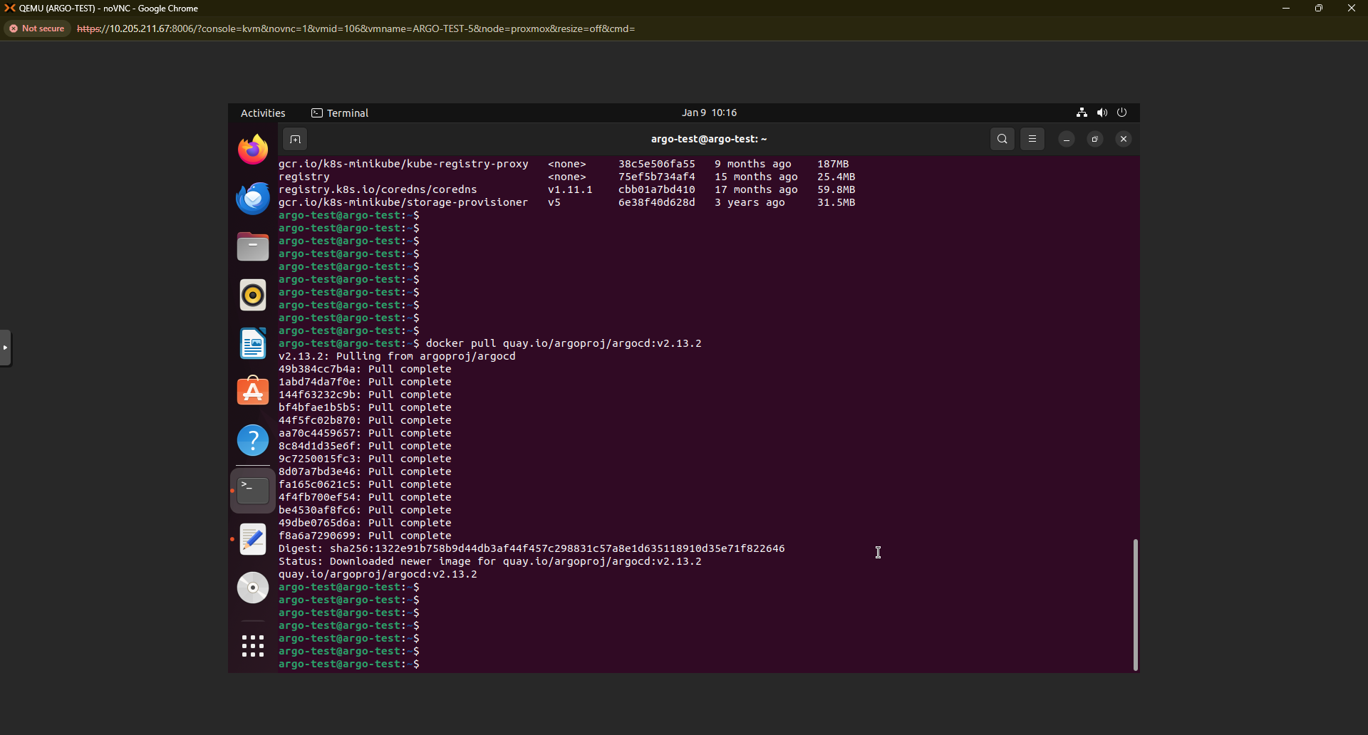

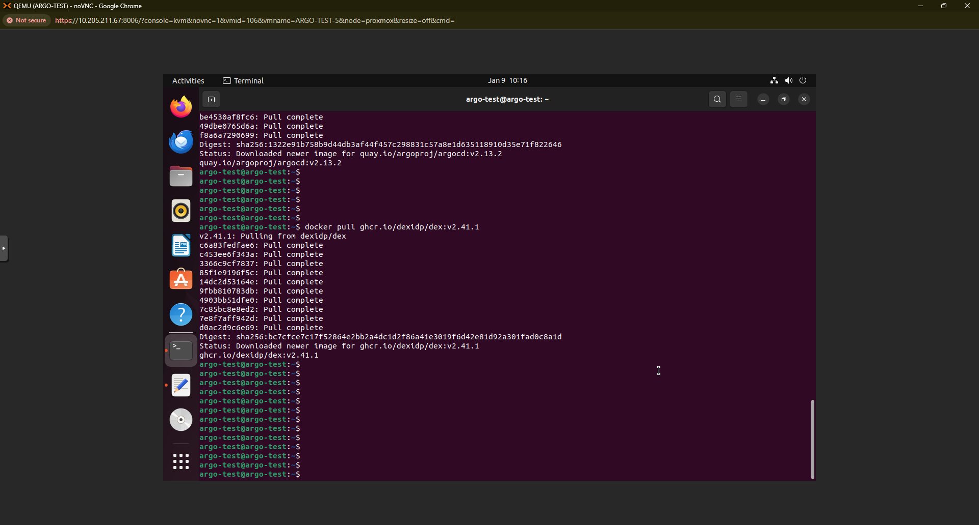

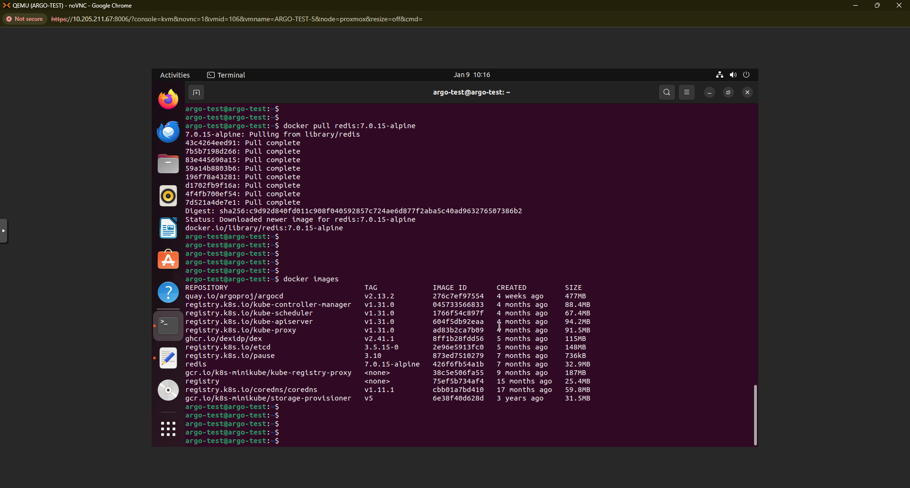

Now, pull the required images from the internet. Images tags might change with time. Kindly refer latest images

**docker pull** [**quay.io/argoproj/argocd:v2.13.2**](http://quay.io/argoproj/argocd:v2.13.2)

**docker pull** [**ghcr.io/dexidp/dex:v2.41.1**](http://ghcr.io/dexidp/dex:v2.41.1)

**docker pull redis:7.0.15-alpine**

Check the availability of the images.

**docker images**

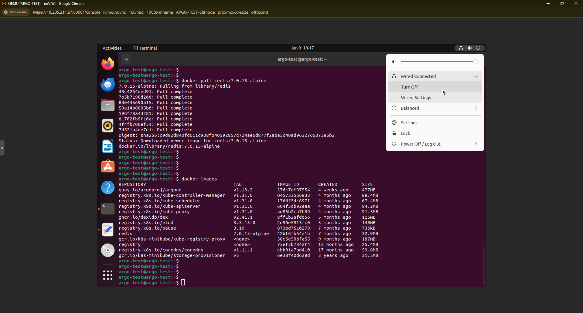

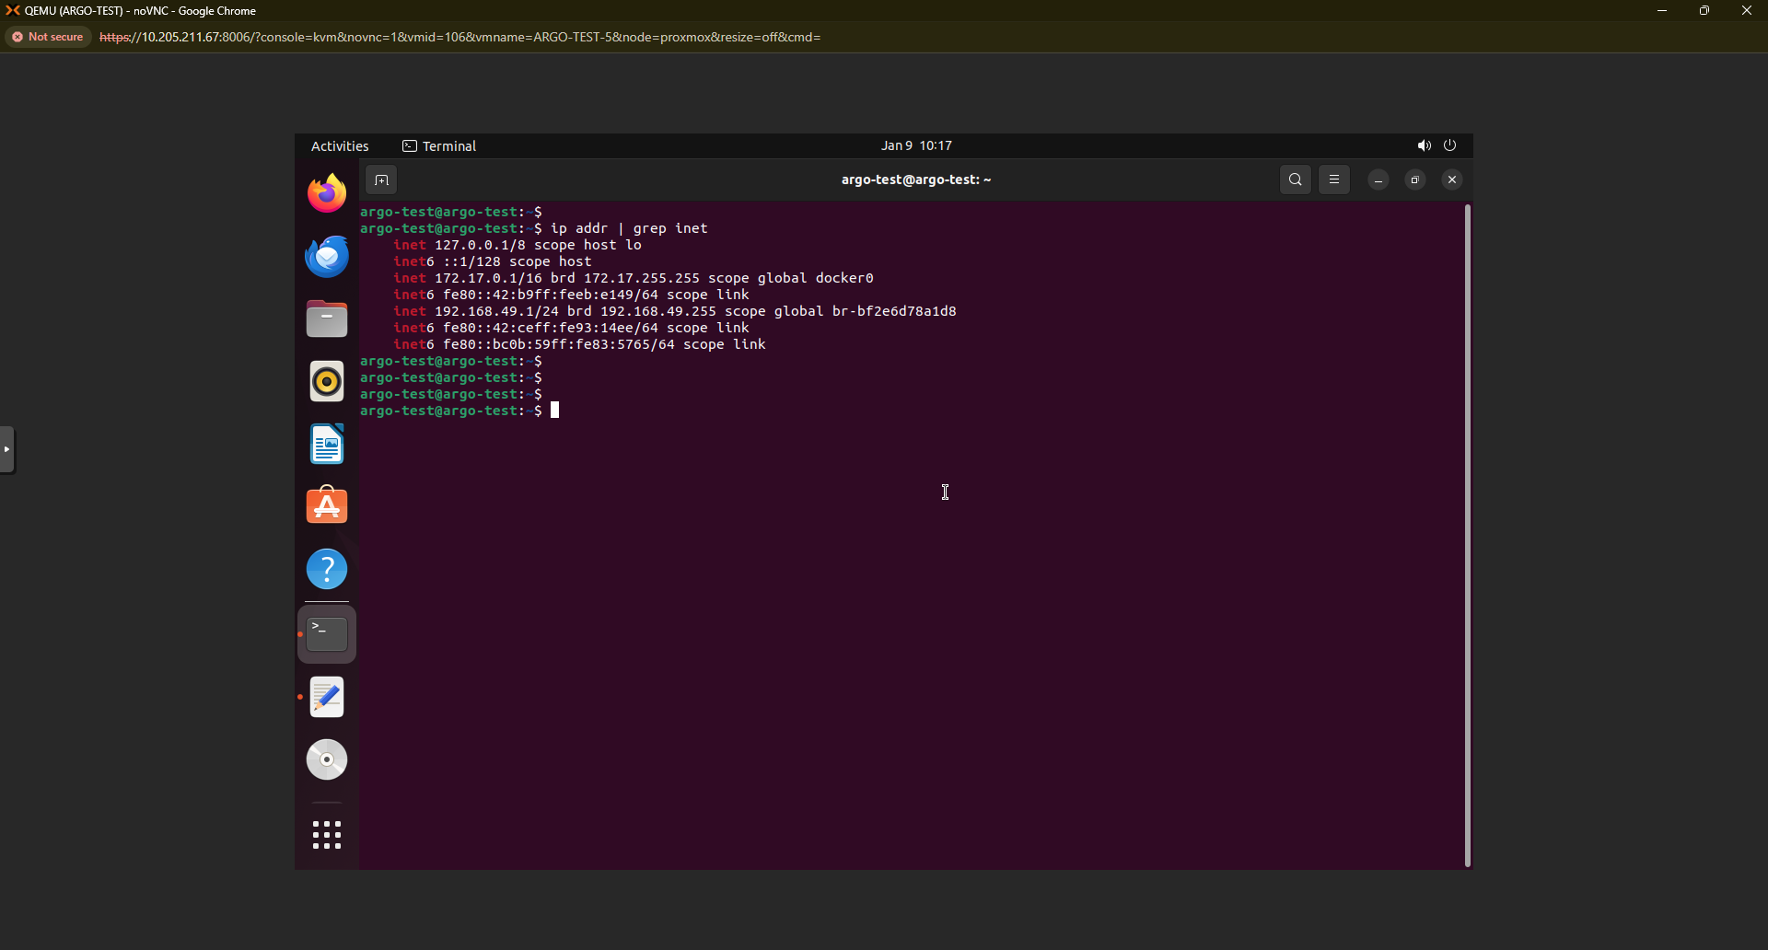

Now, turn off Internet connection on your VM to make it an air gapped environment. Verify it with the below command.

**ip addr | grep inet**

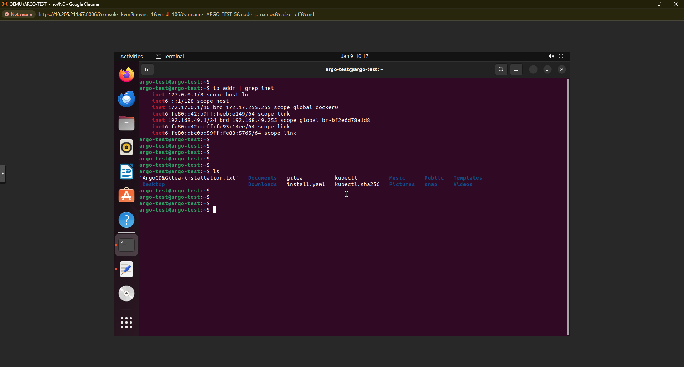

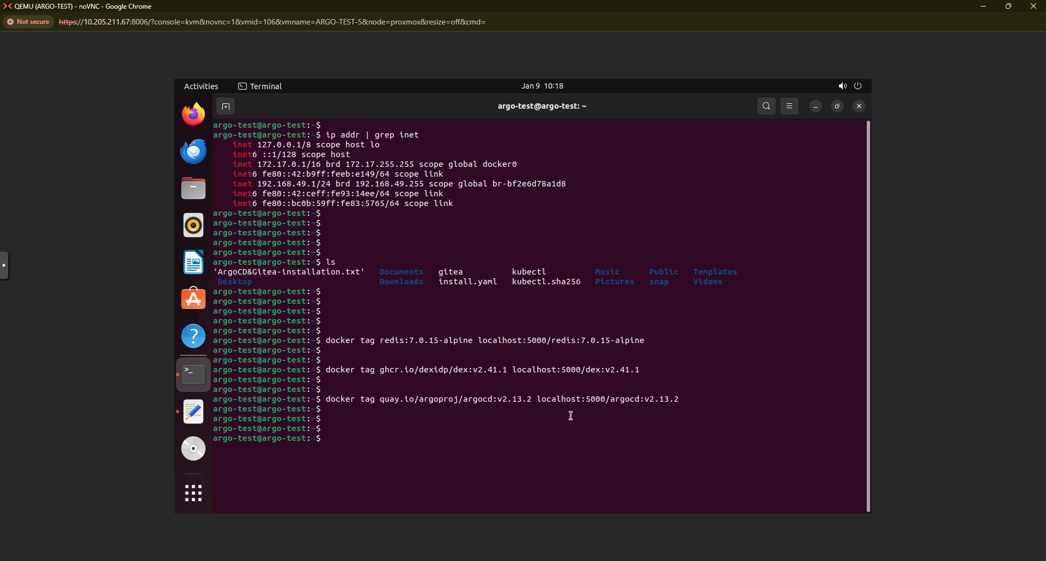

Now, change the tags for the images to push them to the local registry.

**docker tag redis:7.0.15-alpine localhost:5000/redis:7.0.15-alpine**

**docker tag ghcr.io/dexidp/dex:v2.41.1 localhost:5000/dex:v2.41.1**

**docker tag quay.io/argoproj/argocd:v2.13.2 localhost:5000/argocd:v2.13.2**

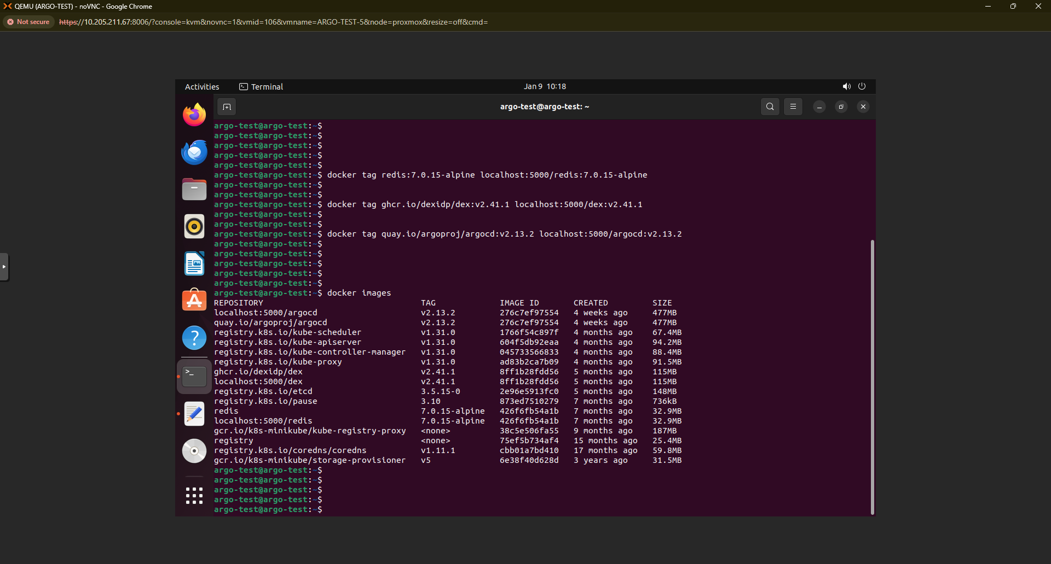

Verify the images tags and naming convention.

**docker images**

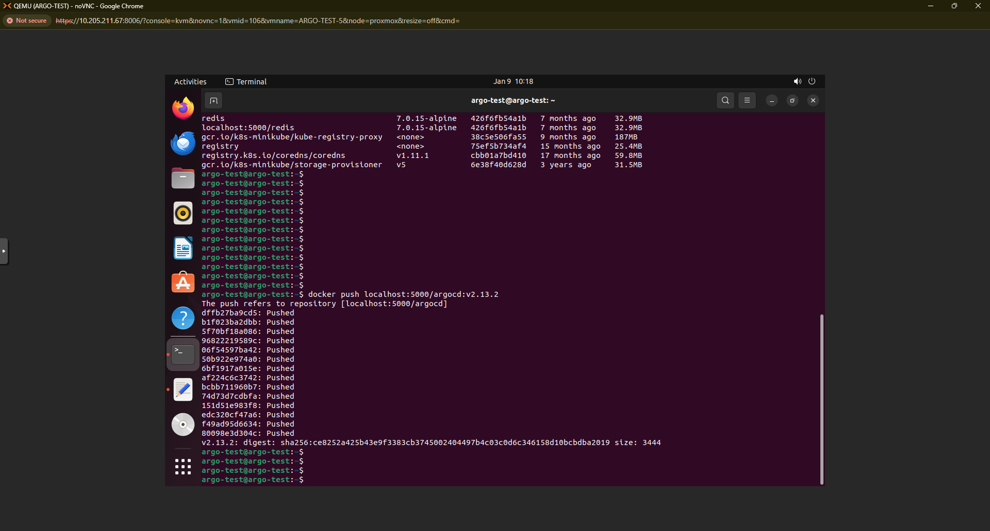

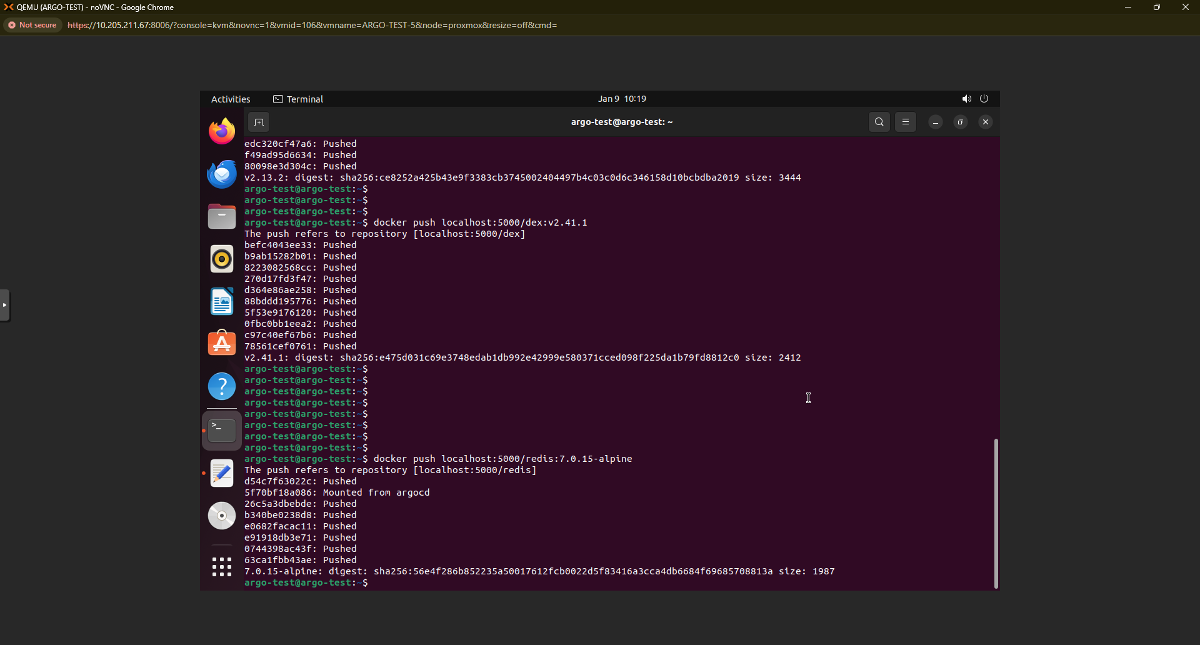

Push the images to the local image registry. Here it is available inside Minikube.

**docker push localhost:5000/argocd:v2.13.2**

**docker push localhost:5000/dex:v2.41.1**

**docker push localhost:5000/redis:7.0.15-alpine**

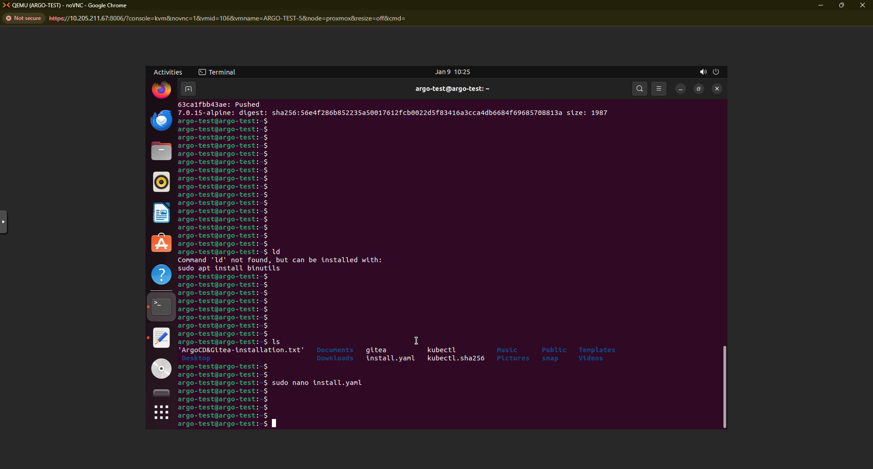

Change the image names in the **install.yaml** file with the above pushed images in the local image registry. This is a mandatory step to access locally present images.

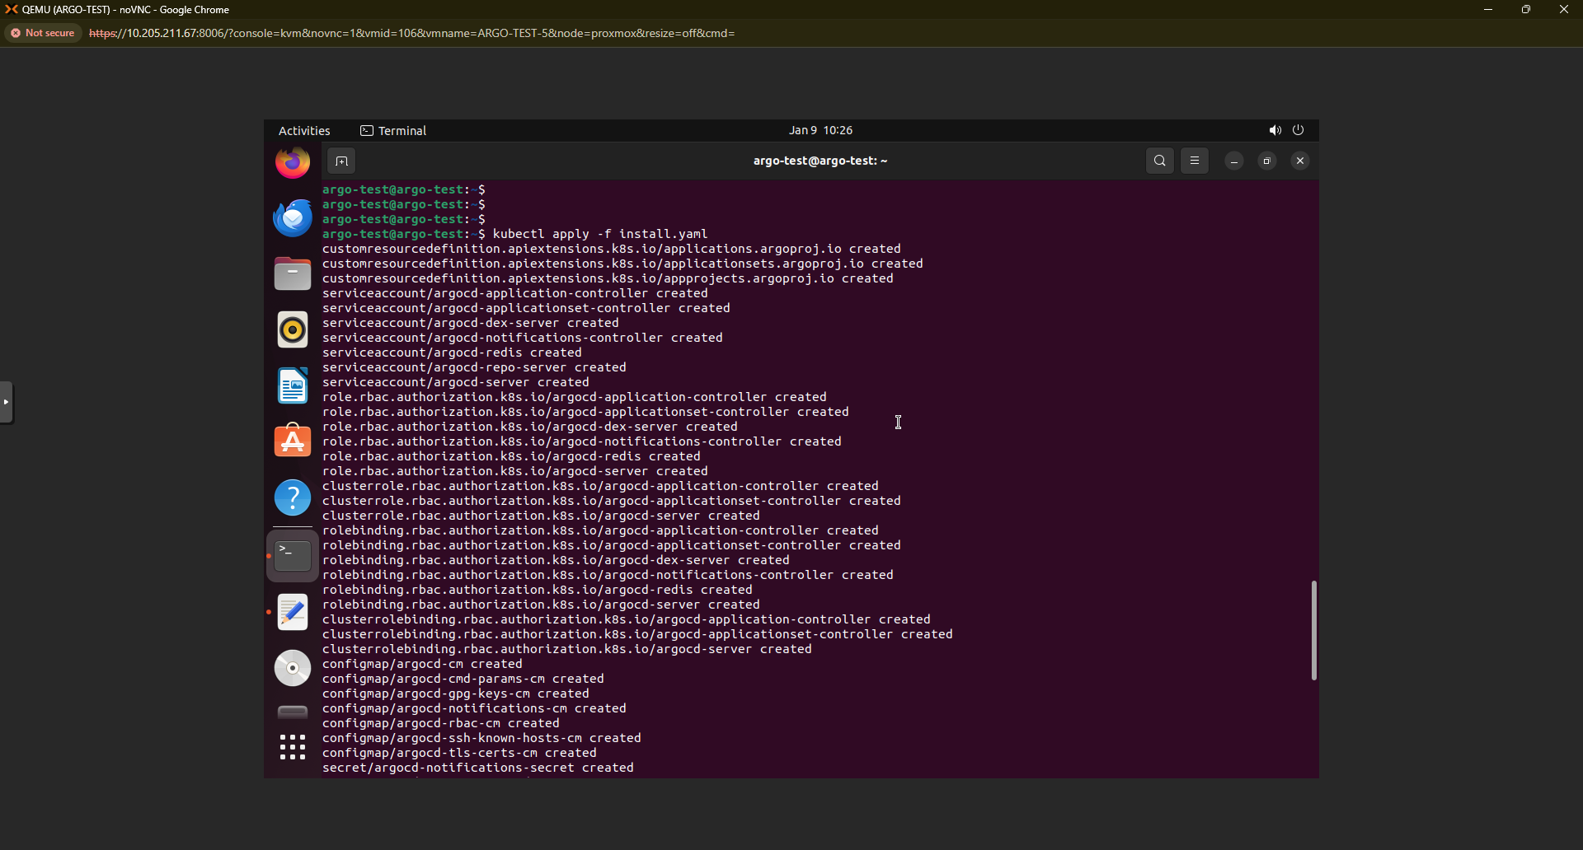

Apply the configuration in the Minikube cluster.

**kubectl apply -f install.yaml**

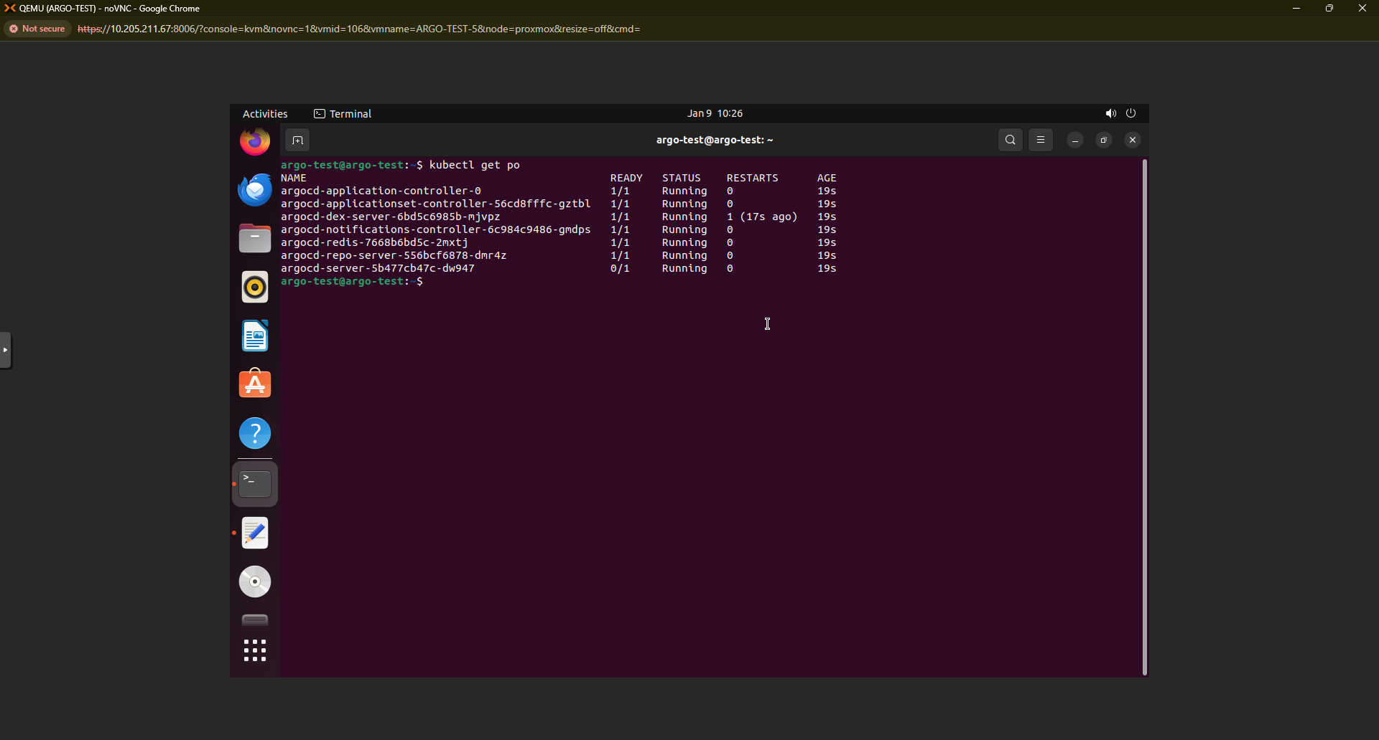

Verify it with the below commands.

**kubectl get pod**

**kubectl get svc**

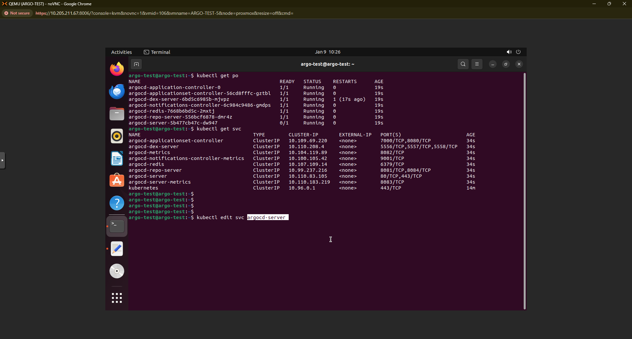

Now, Edit the service file to make it accessible from the browser (internet or intranet). Change service type from **ClusterIP** to **NodePort.**

**kubectl edit svc argocd-server**

**kubectl get svc**

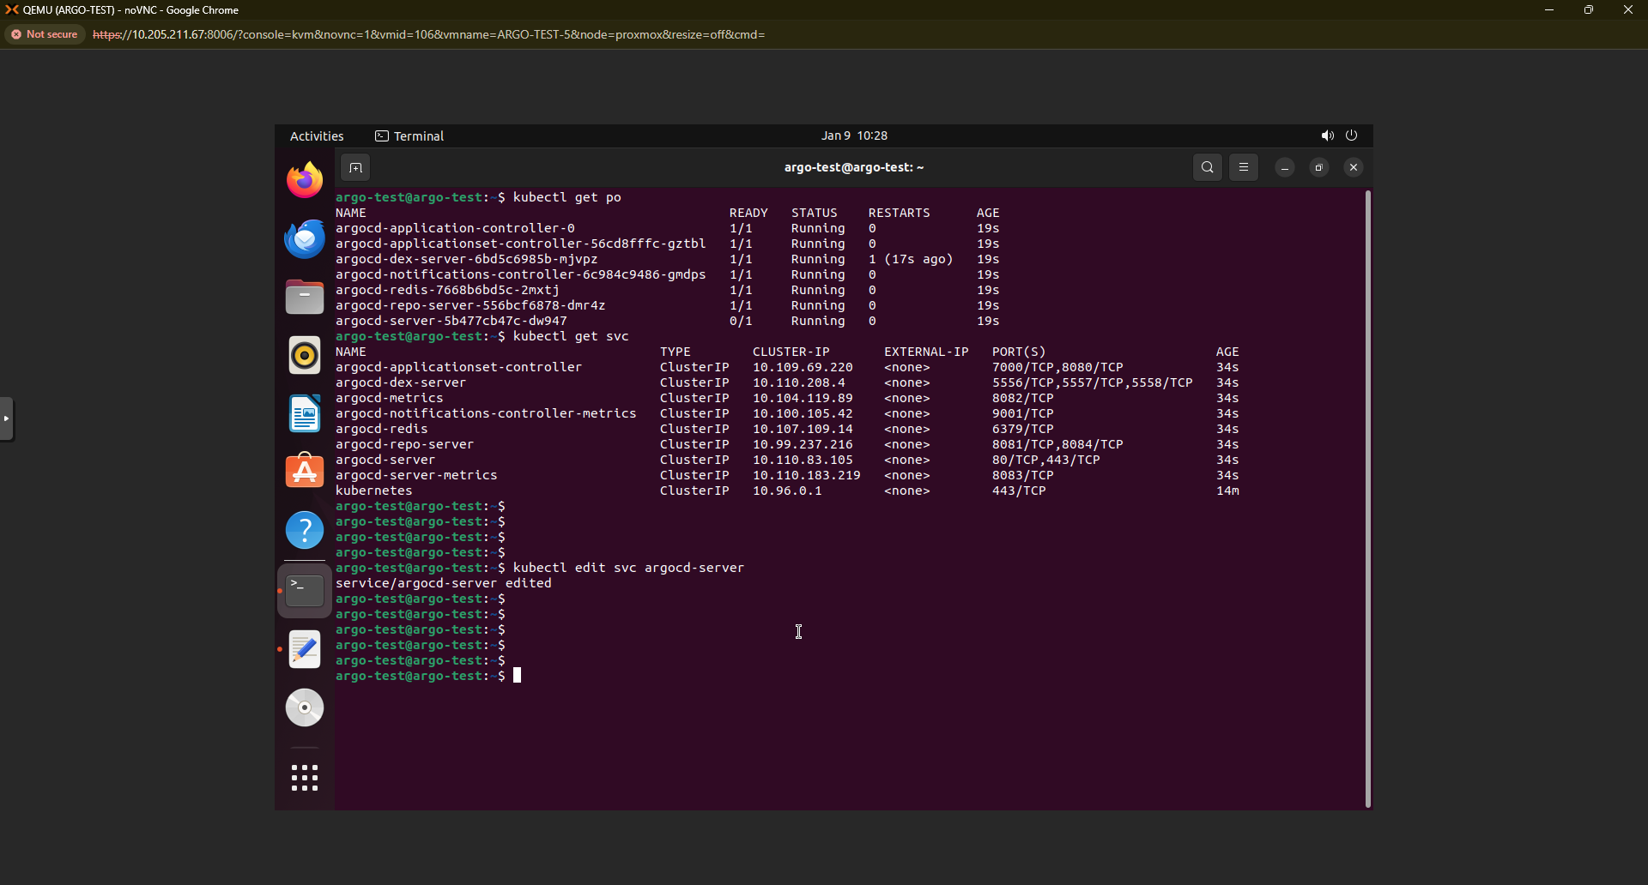

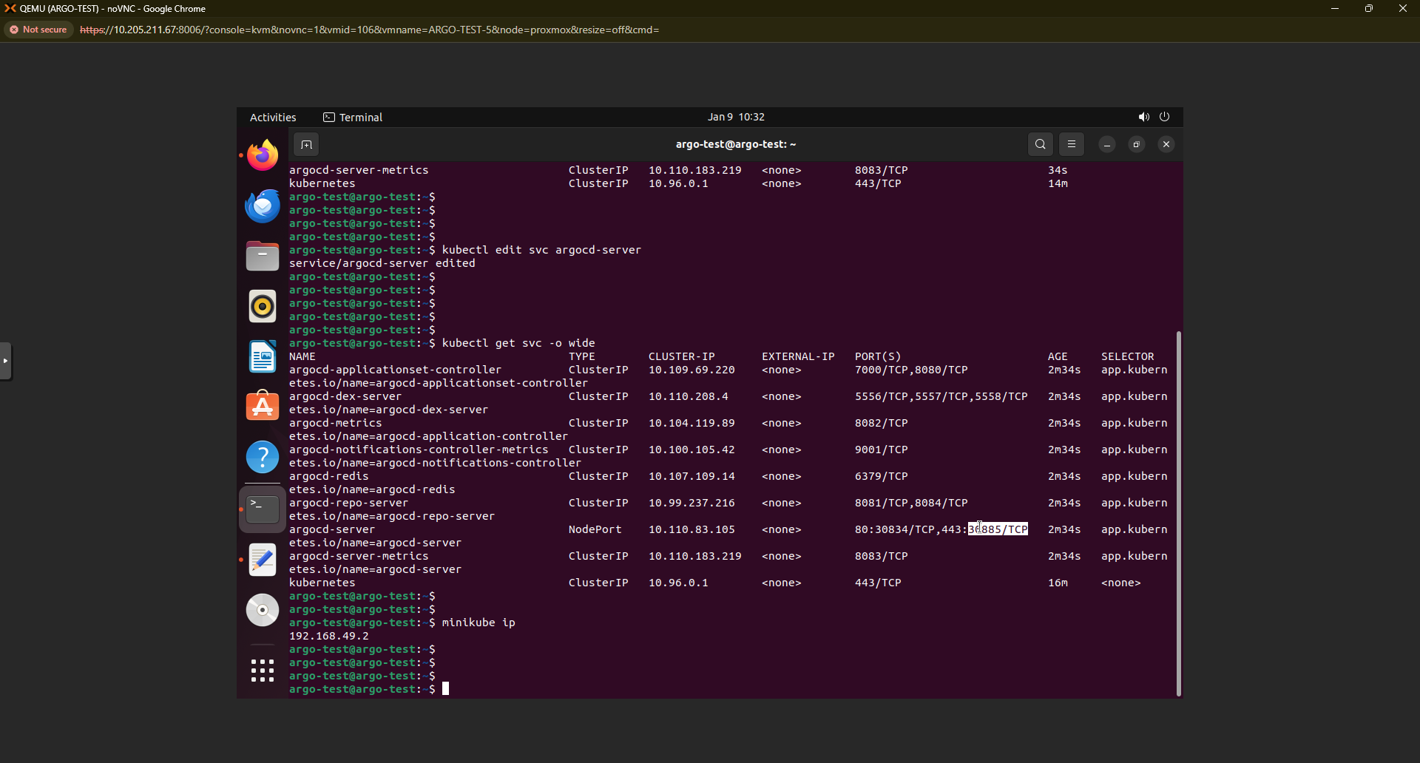

Since we are using Minikube as a kubernetes cluster, We can access it using Minikube IP.

**minikube ip**

**kubectl get secret**

Get the secret value and decrypt it to use it for authentication. Get that by executing the below command.



**kubectl -n argocd get secret argocd-initial-admin-secret -o jsonpath="{.data.password}" | base64 -d**

Access the application from the browser with Minikube IP and that particular service NodePort.

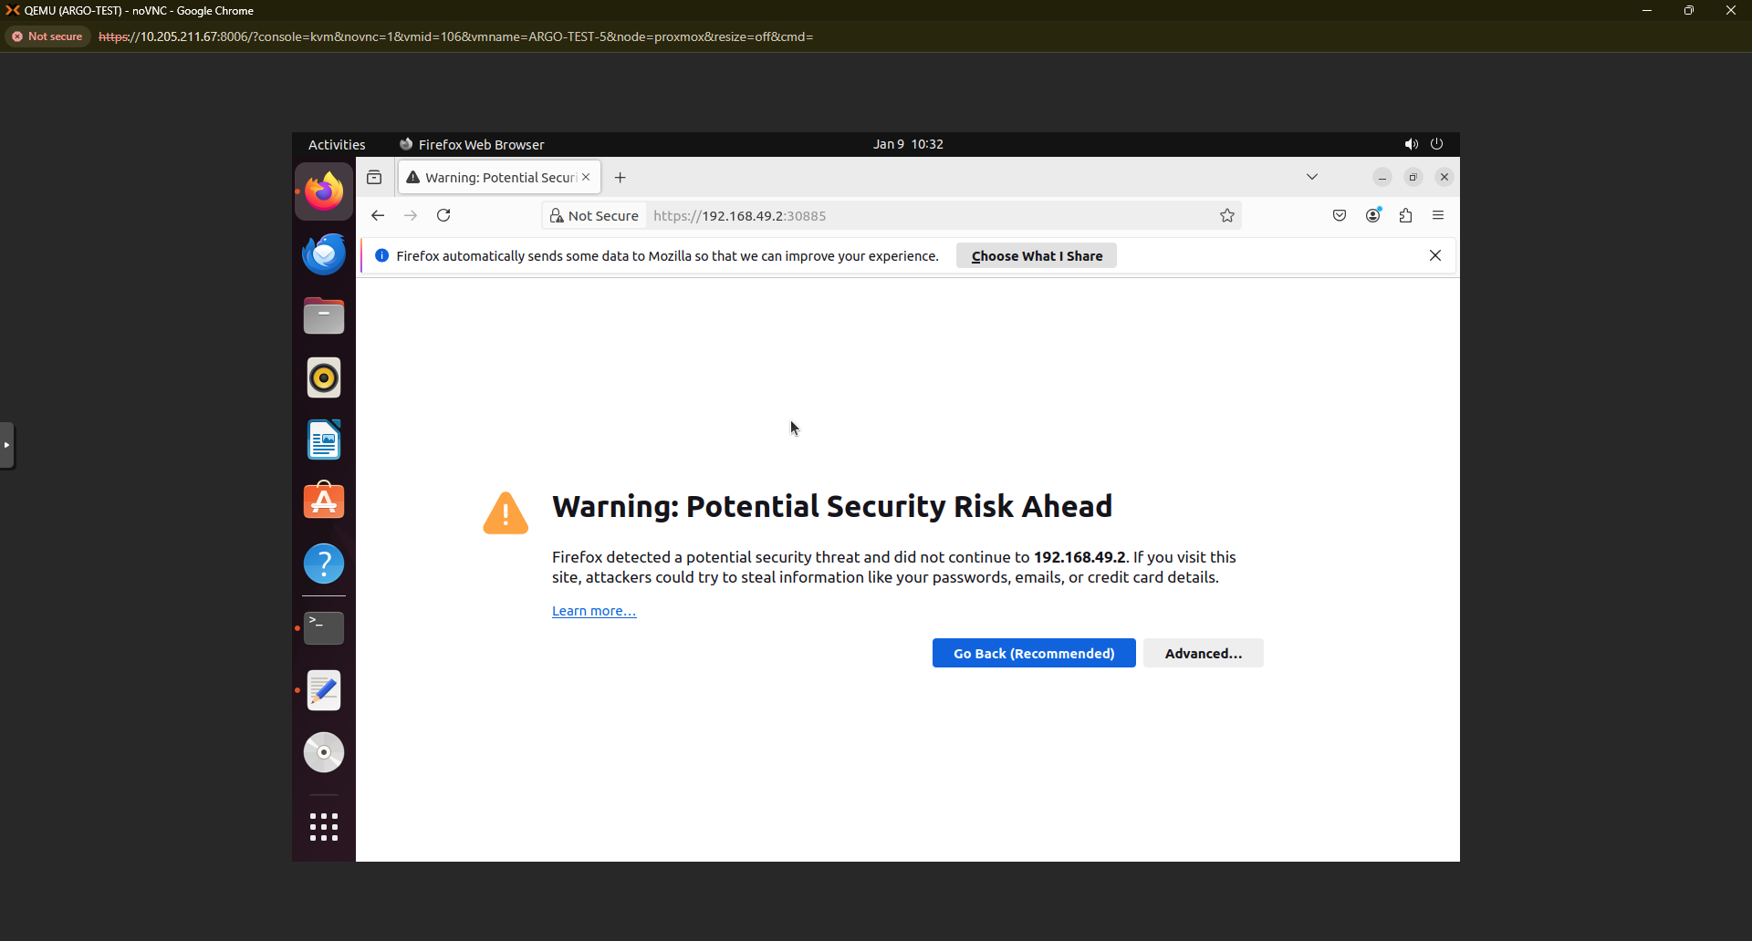

Username is **“admin”** and password you can get by running the above command.

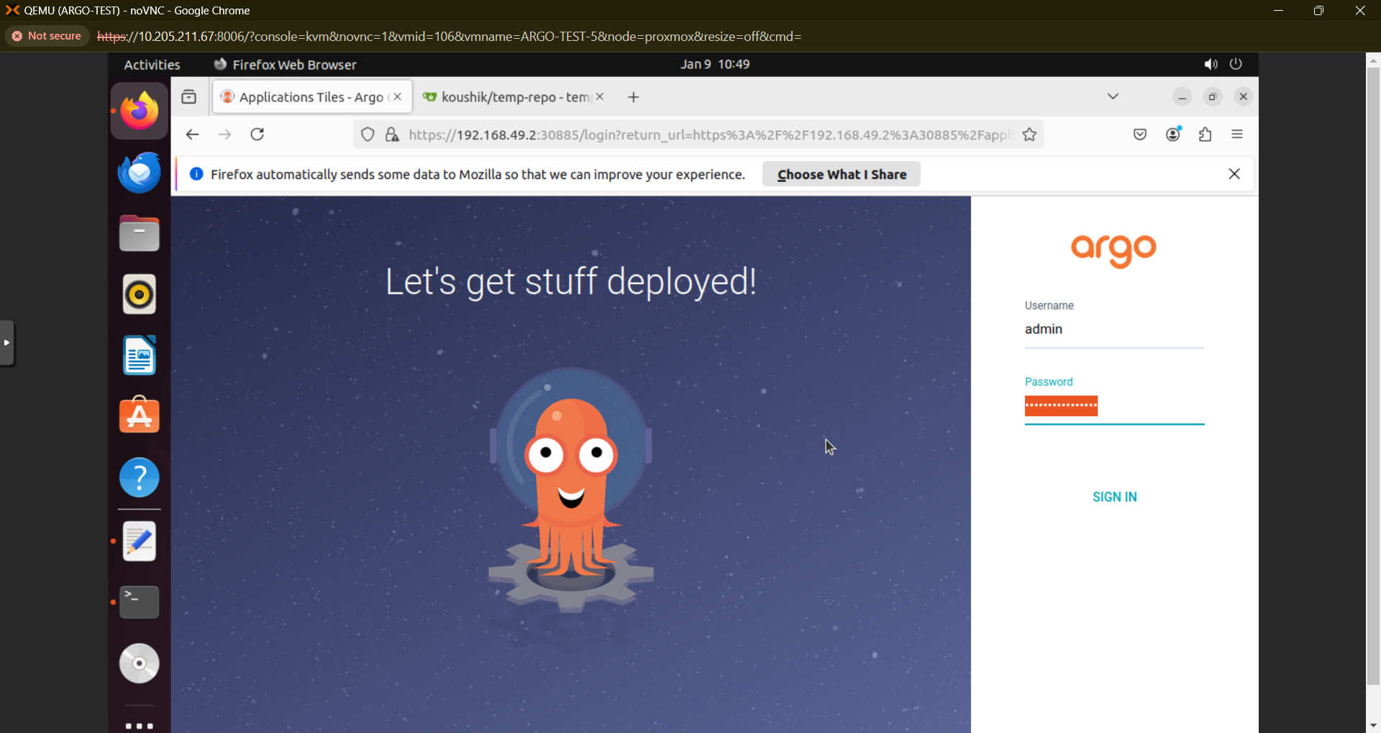



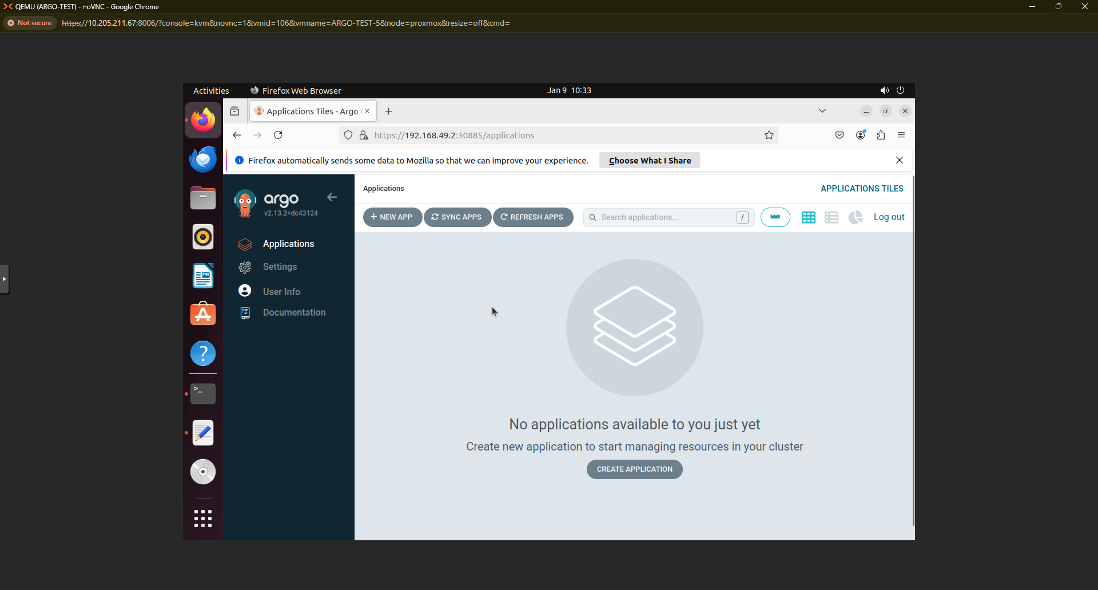

Now, Let’s install Gitea as a service in the VM.

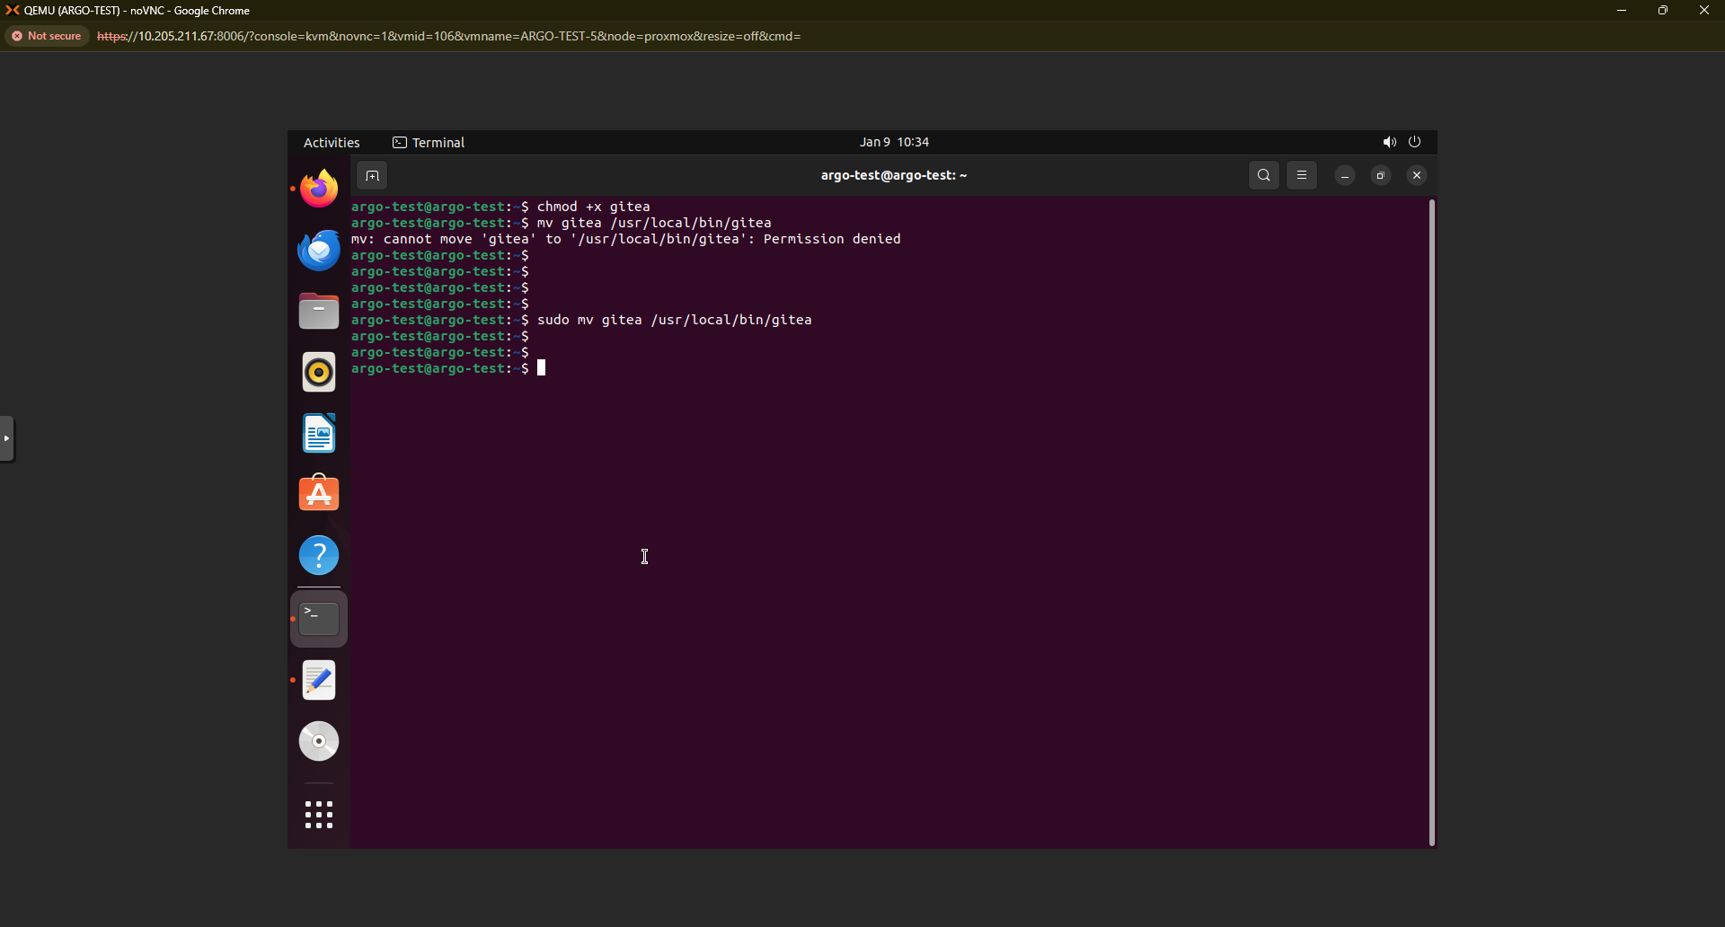

Change the permissions and create the below folders. If any command didn’t work, try executing it with sudo command.

**chmod +x gitea**

**sudo mv gitea /usr/local/bin/gitea**

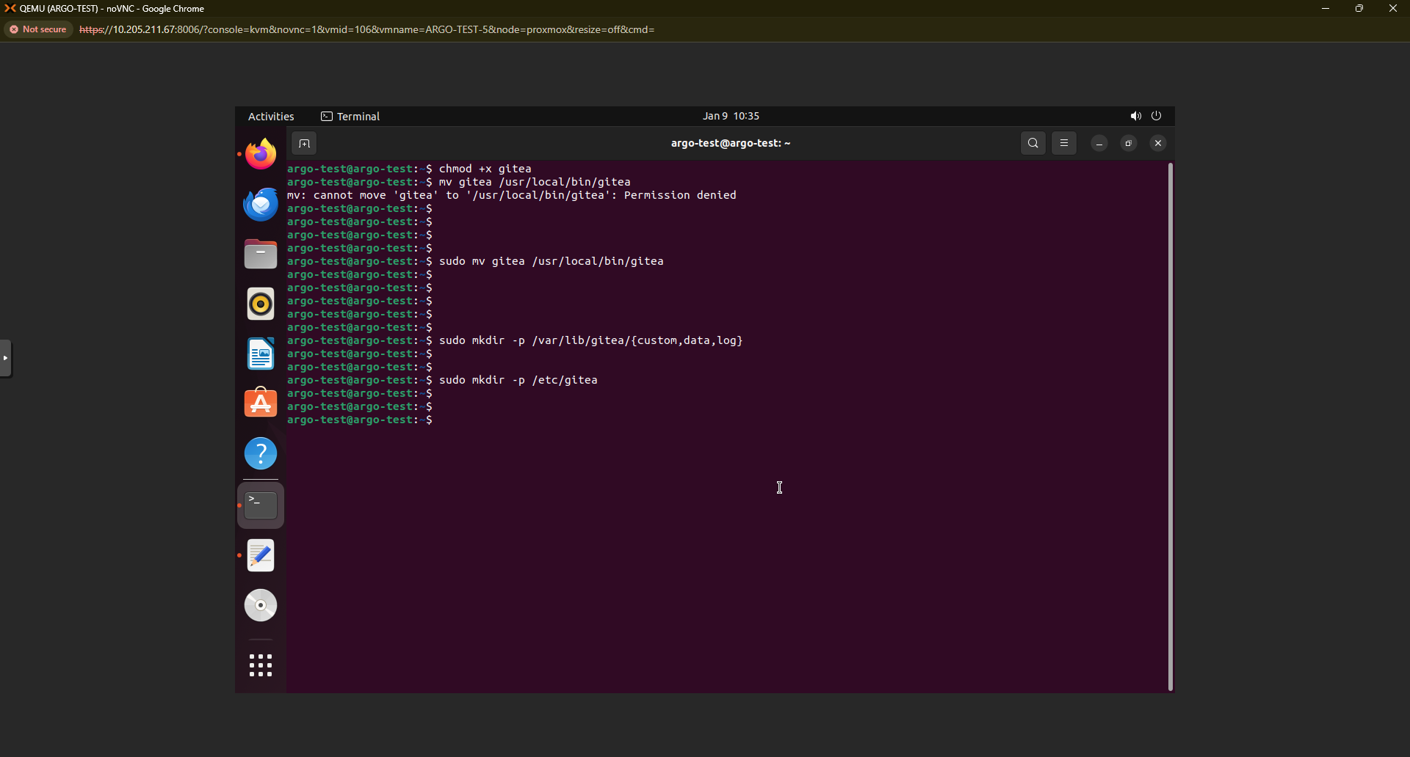

**sudo mkdir -p /var/lib/gitea/{custom,data,log}**

**sudo mkdir -p /etc/gitea**

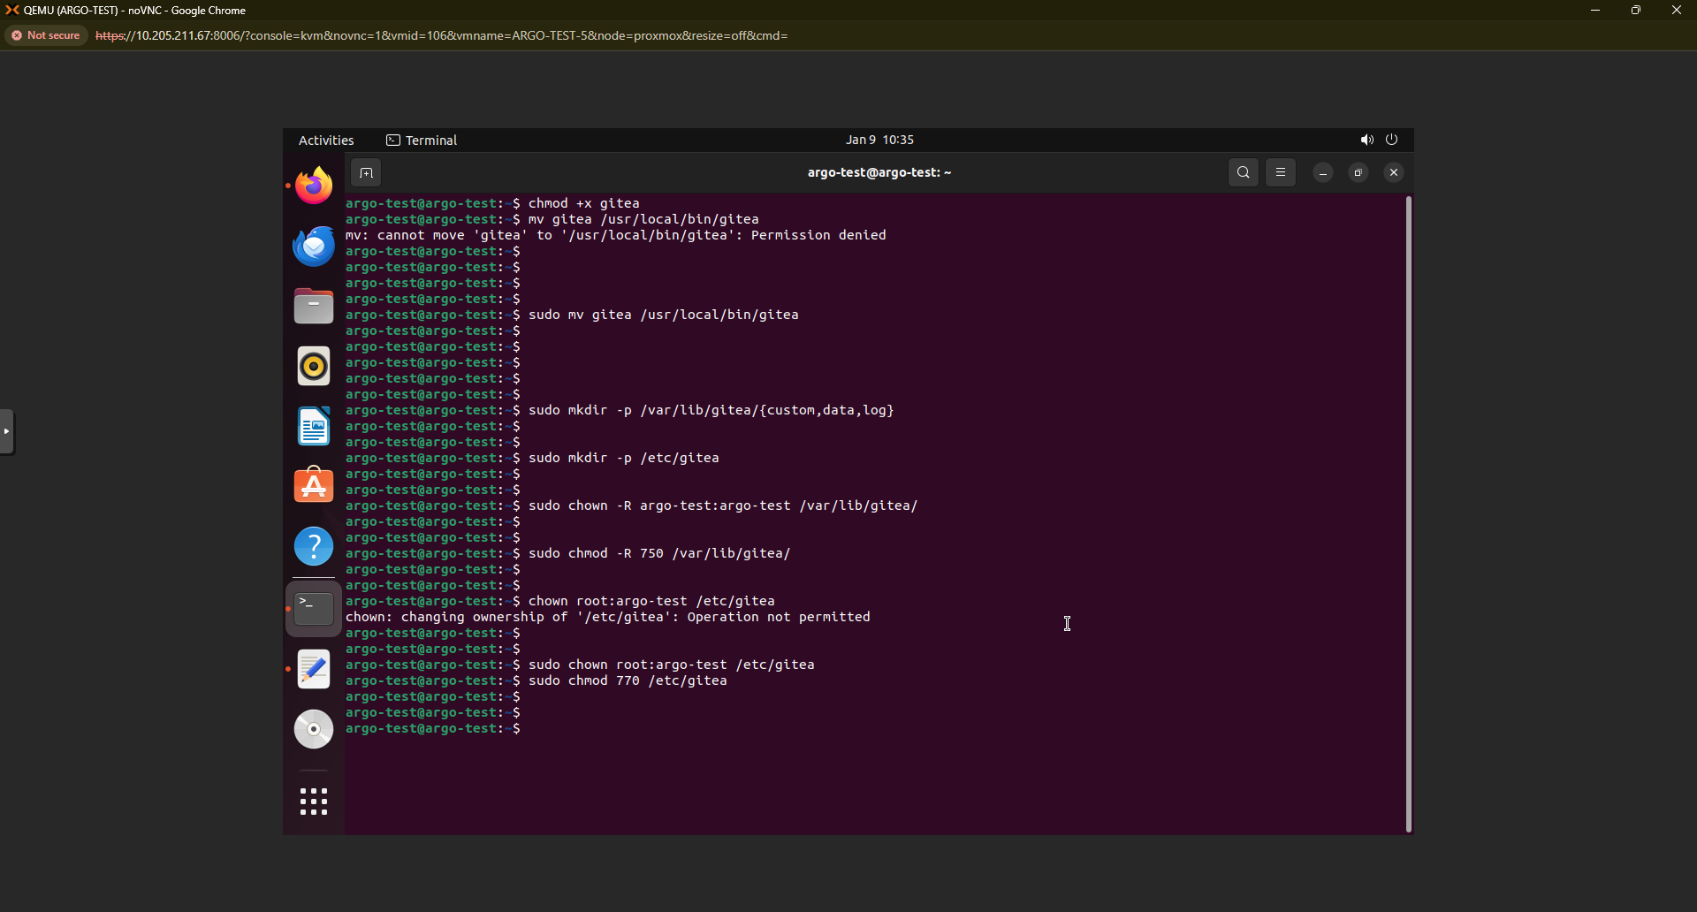

**sudo chown -R argo-test:argo-test /var/lib/gitea/**

**sudo chmod -R 750 /var/lib/gitea/**

**sudo chown root:argo-test /etc/gitea**

**sudo chmod 770 /etc/gitea**

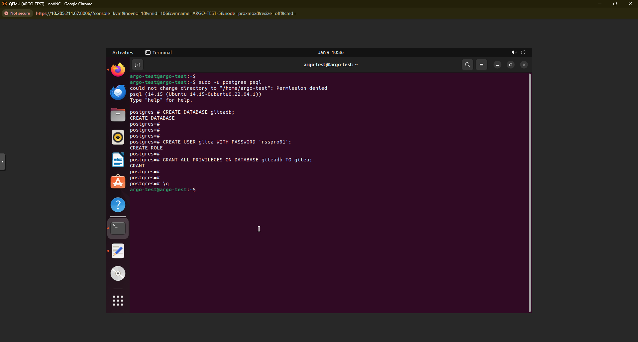

Connect to postgres user, create a database and create a user and grant him permissions

**sudo -u postgres psql**

**CREATE DATABASE giteadb;**

**CREATE USER gitea WITH PASSWORD 'rsspro01';**

**GRANT ALL PRIVILEGES ON DATABASE giteadb TO gitea;**

**\q**

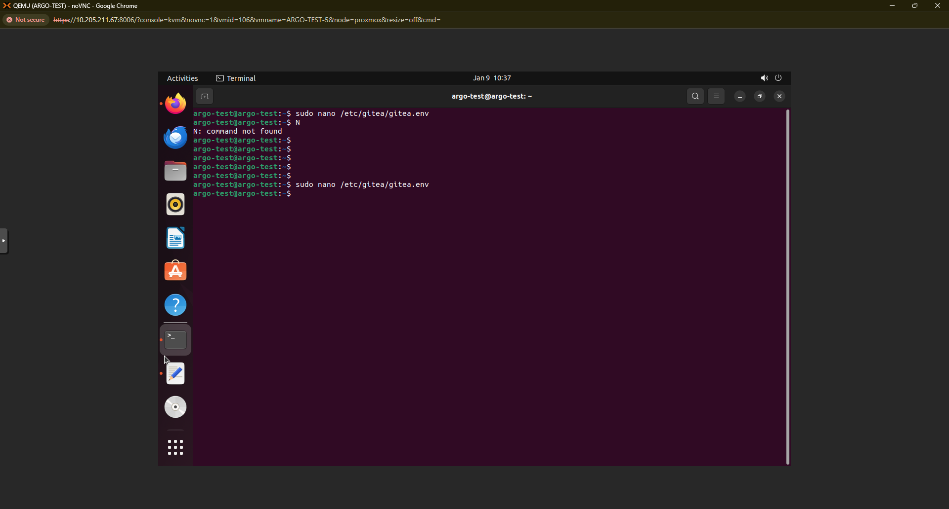

**sudo nano /etc/gitea/gitea.env**

Copy the below 6 lines into gitea.env

**DB_TYPE=postgres**

**DB_HOST=localhost:5432**

**DB_NAME=giteadb**

**DB_USER=gitea**

**DB_PASSWD=rsspro01**

**ROOT_URL=http://localhost:3000**

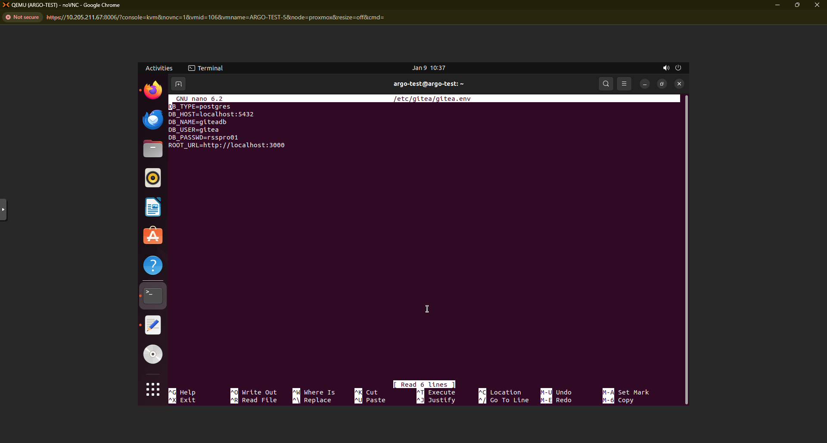

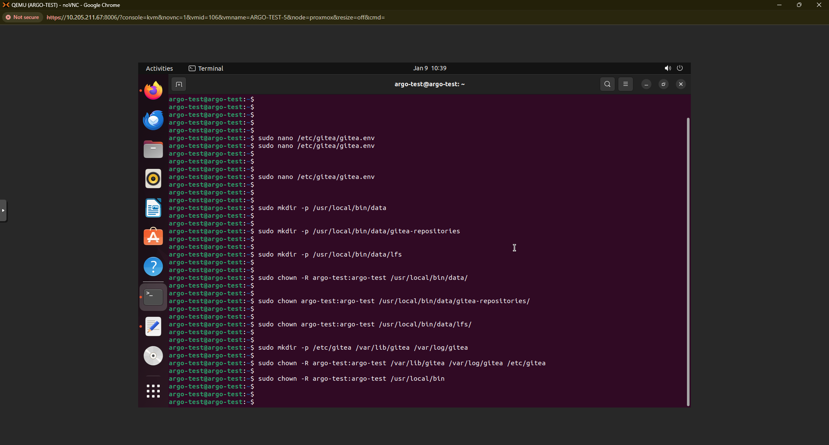

**sudo mkdir -p /usr/local/bin/data**

**sudo mkdir -p /usr/local/bin/data/gitea-repositories**

**sudo mkdir -p /usr/local/bin/data/lfs**

**sudo chown -R argo-test:argo-test /usr/local/bin/data/**

**sudo chown argo-test:argo-test /usr/local/bin/data/gitea-repositories/**

**sudo chown argo-test:argo-test /usr/local/bin/data/lfs/**

Execute the below command just to check if the Gitea service is able to run or not.

**#sudo -u argo-test env $(cat /etc/gitea/gitea.env | xargs) gitea web**

Run the below commands.

**sudo mkdir -p /etc/gitea /var/lib/gitea /var/log/gitea**

**sudo chown -R argo-test:argo-test /var/lib/gitea /var/log/gitea /etc/gitea**

**sudo chown -R argo-test:argo-test /usr/local/bin**

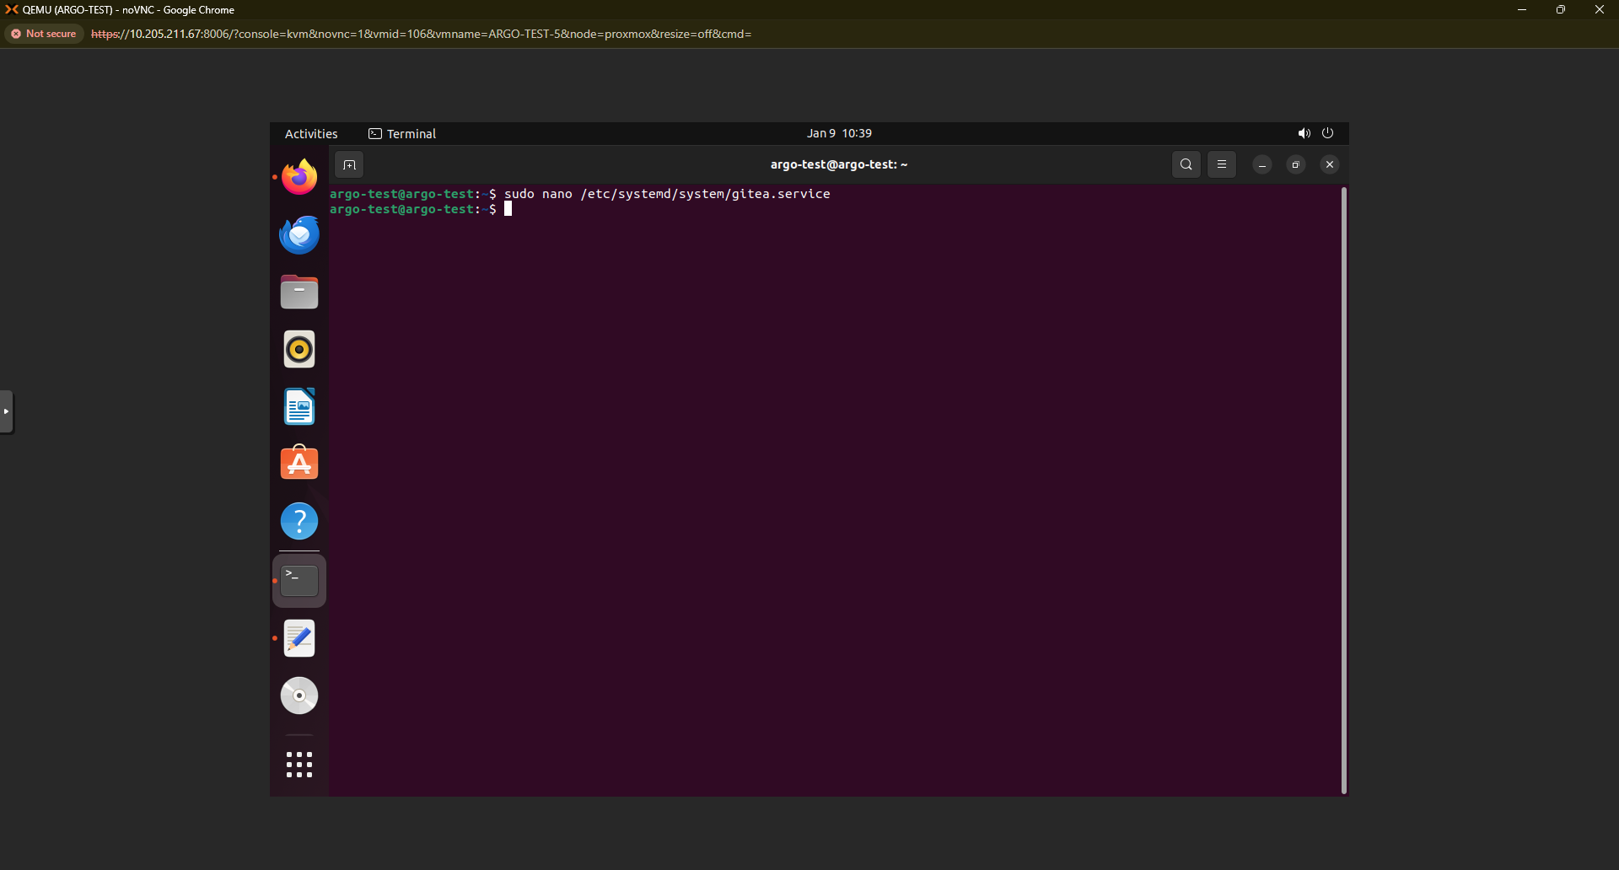

**sudo nano /etc/systemd/system/gitea.service**

copy the below configuration into the gitea.service file. Make sure to add the correct user in the configuration file. My username is argo-test. Change that with your username in the VM.

**[Unit]**

**Description=Gitea Service**

**After=network.target**

**[Service]**

**User=argo-test**

**Group=argo-test**

**WorkingDirectory=/var/lib/gitea**

**EnvironmentFile=/etc/gitea/gitea.env**

**ExecStart=/usr/local/bin/gitea web**

**Restart=always**

**StandardOutput=syslog**

**StandardError=syslog**

**SyslogIdentifier=gitea**

**[Install]**

**WantedBy=multi-user.target**

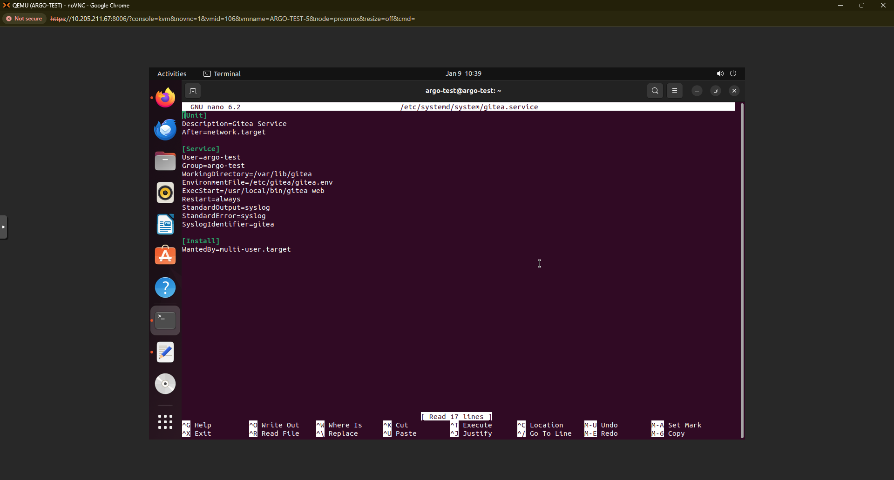

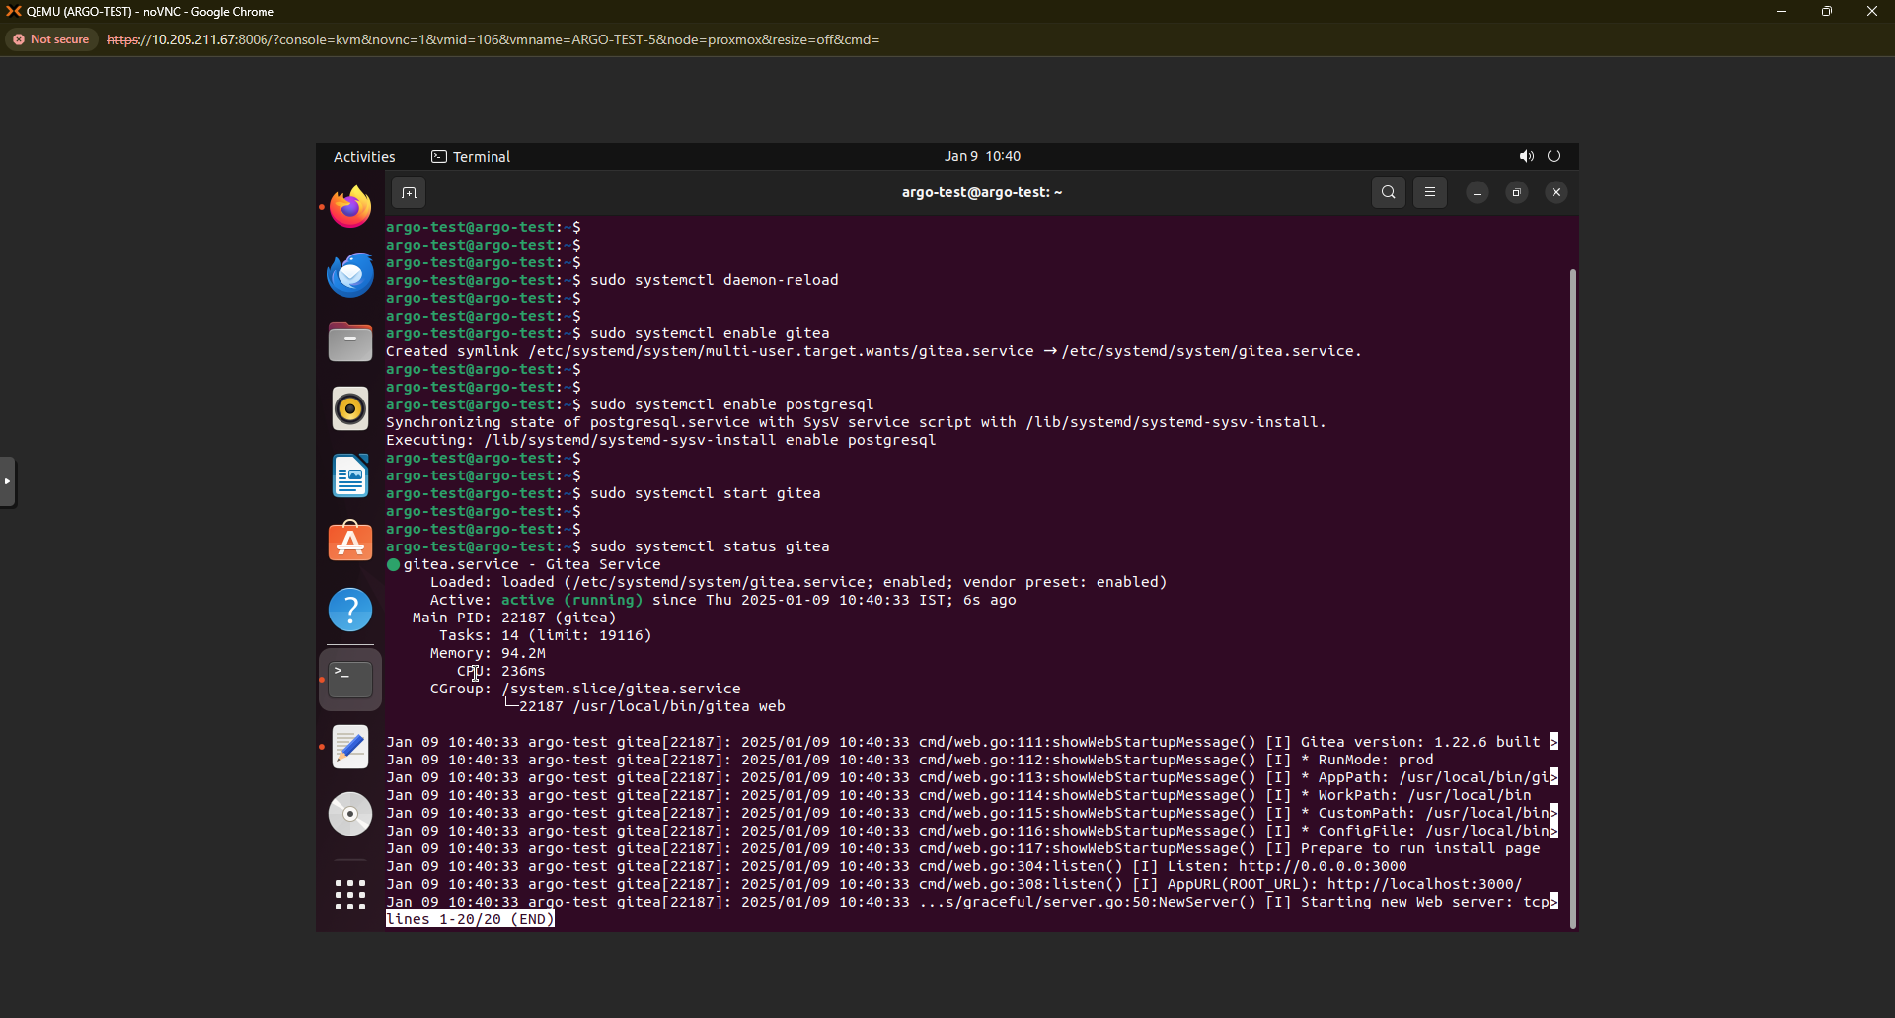

**sudo systemctl daemon-reload**

**sudo systemctl enable gitea**

**sudo systemctl start gitea**

**sudo systemctl status gitea**

**sudo systemctl enable postgresql**

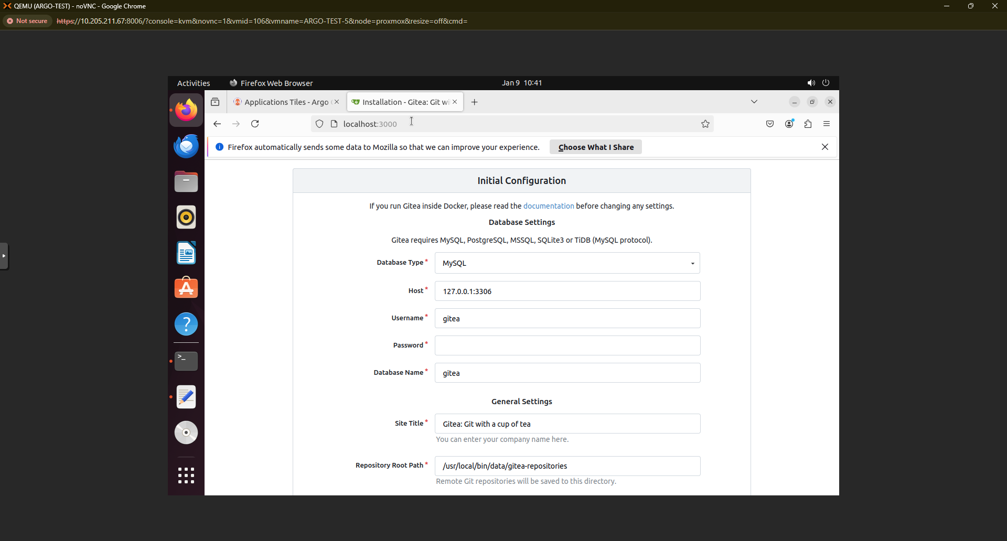

Open browser and access Gitea at **http://localhost:3000**

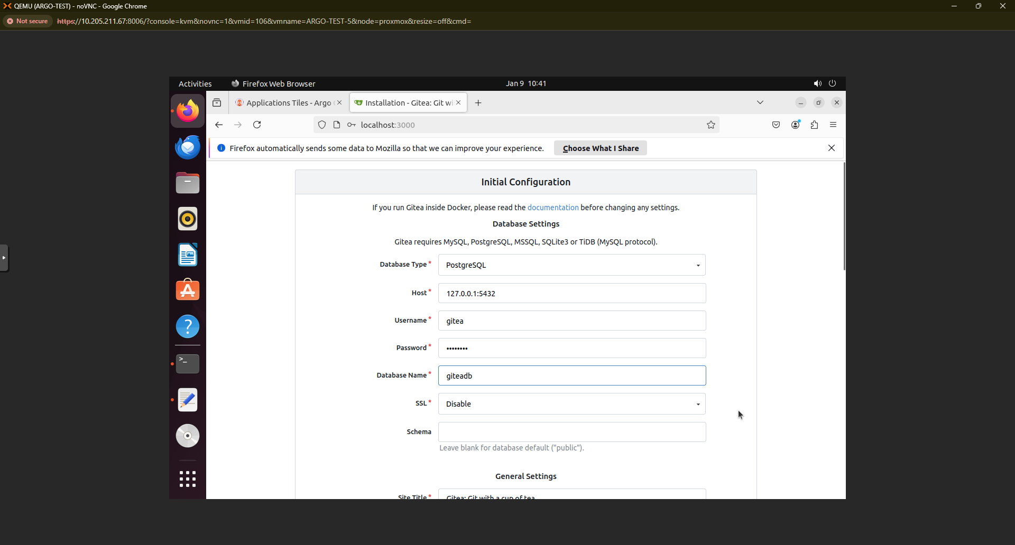

Change the Database and its configuration with the below configuration.

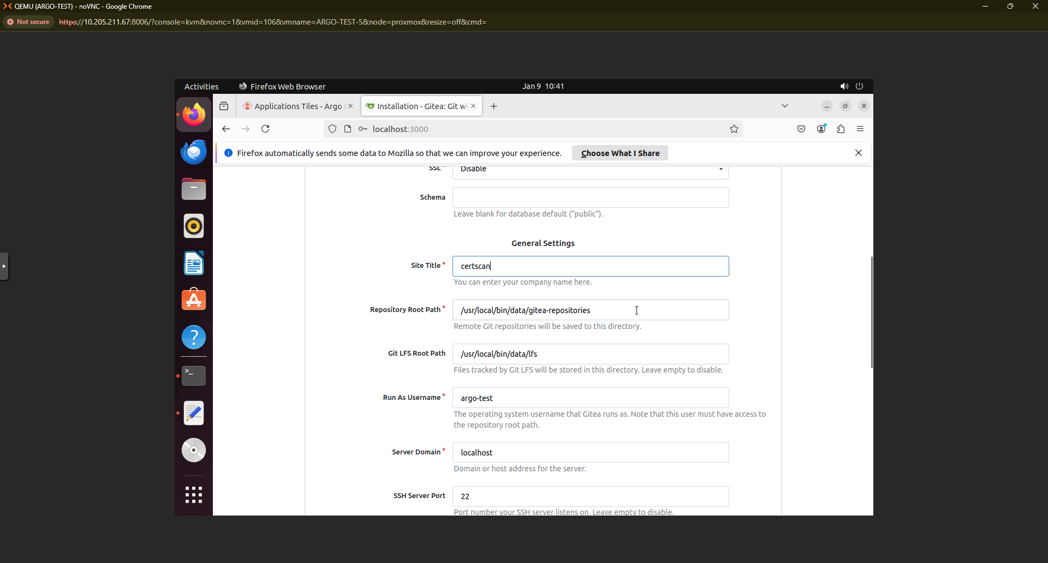

And add administrator data

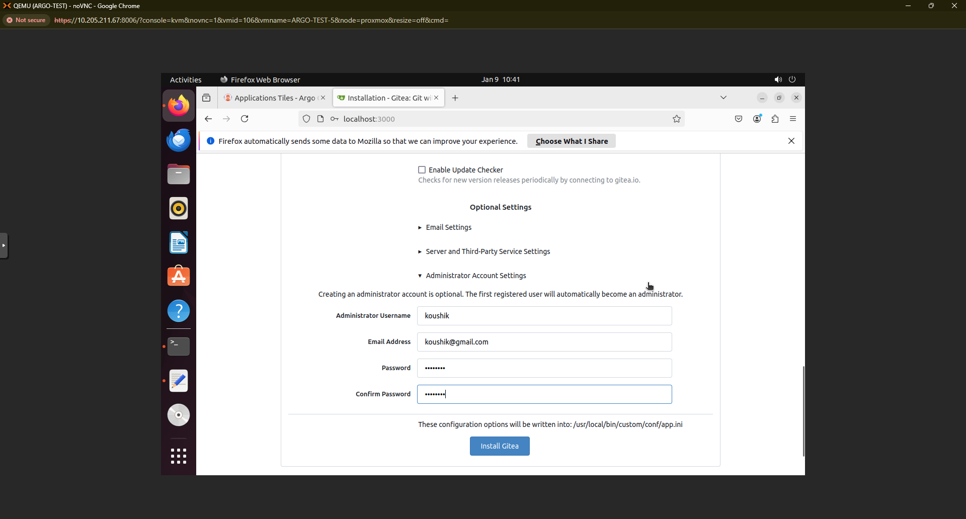

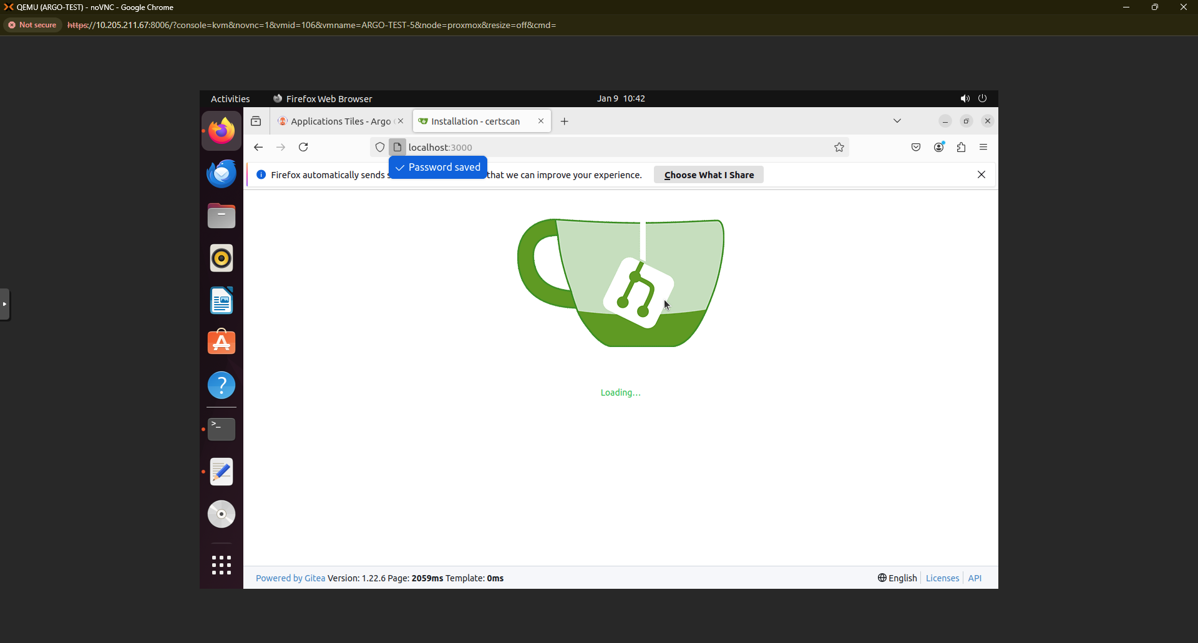

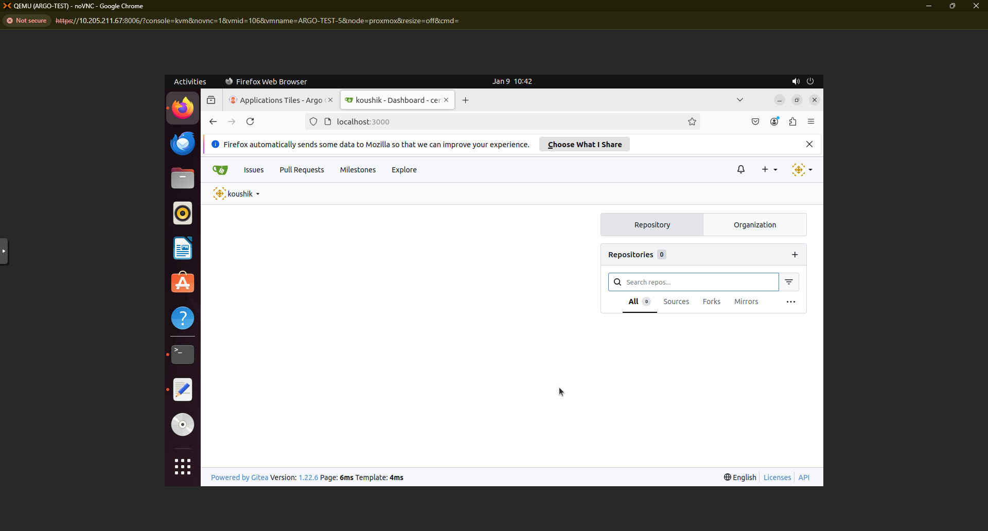

Try creating a sample repository on the Gitea server.

